Pauli Murray: Visionary for Justice
Secondary Grades Curriculum Guide

The Rev. Dr. Pauli Murray’s life as a 20th century human rights activist offers learners a compelling personal lens for learning about a crucial part of American history and writing as a tool for personal expression and civic engagement.

About This Curriculum Guide

This curriculum is designed and developed for 8th grade Durham Public Schools ELA and SS Units 1, 2, 3, and 4, but can be adapted to fit all grade levels and/or other Units. It is aligned with the State Common Core guidelines to ensure it is relevant to you and your classroom.

Please feel free to leave your feedback after using any or all parts of this Curriculum Guide by completing the Educator Feedback Form: https://forms.gle/sReZY1hhxB2tNHeH7

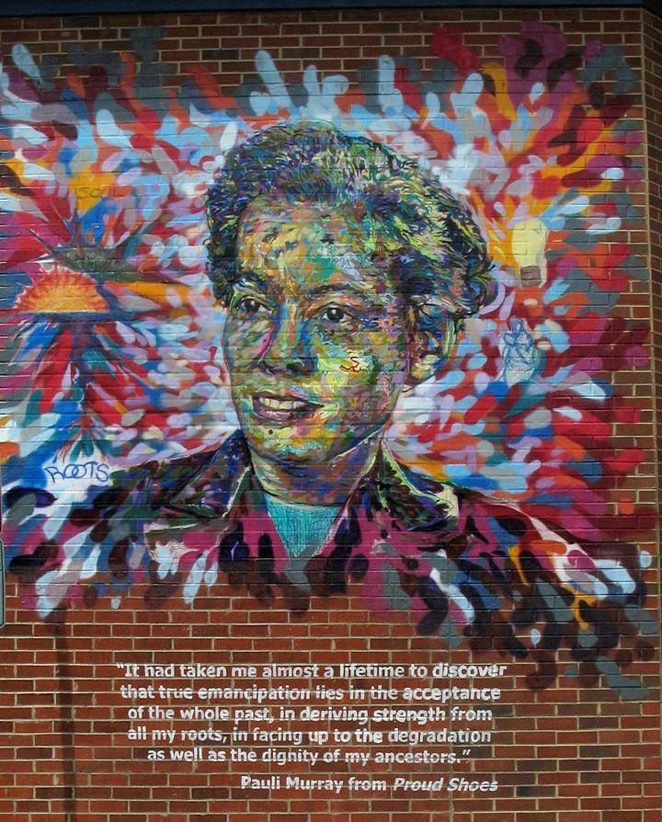
“True emancipation lies in the acceptance of the whole past, in deriving strength from all my roots, in facing up to the degradation as well as the dignity of my ancestors.” -- Pauli Murray

The curriculum centers on the theme: “How do words and images shape our world?” For eighth and higher grade levels, the theme takes on the variation, “Telling and documenting our stories as activism.”

Our goal is for students to advance their skills in critical thinking, narrative writing, creative expression, and to gain a greater awareness of the historical contexts in which Murray continued to fight for human rights. We also hope students will walk away from each activity with insights about the ways history, politics, and identity are connected and a view of themselves as active citizens in their own communities.

Who was Pauli Murray?
The Rev. Dr. Pauli Murray, 1910-1985, was an accomplished American activist who believed in justice, reconciliation, and freedom. They championed the cause of human rights through their work as an author, educator, lawyer, feminist, poet and priest.

Most of us divide our identities in categories such as race, gender, class and sexuality. Pauli Murray resisted this by seeking an integrated body, mind and spirit that embraced all of her identities as a woman, a person of color, a worker, and a member of the LGBTQ community. Descendant from slaves and slave owners, they were a person ahead of their time. Pauli Murray refused to sit in the back of the bus fifteen years before Rosa Parks refused to give up her seat; Murray organized restaurant sit-downs in the nation's capital 20 years before the Greensboro sit-ins.

Pauli Murray became America's first female African-American Episcopal priest 123 years after her enslaved grandmother was baptized at Chapel of the Cross in Chapel Hill, NC, and in 2012 Murray was named an Episcopal saint. Murray challenged doctors in the 1930s to embrace new knowledge about gender and sexuality to address their struggle with gender non-conformity through hormone treatments. As Eleanor Holmes Norton said, Pauli Murray not only lived on the edge of history, Murray seemingly "pulled it along with her.”

Who are we?

The Pauli Murray Center is a nationally significant history site, anchored by Pauli Murray’s childhood home built by her grandparents in 1898 at 906 Carroll Street in Durham, North Carolina. By connecting history to contemporary human rights issues, the Pauli Murray Center will activate visitors of all ages to stand up for peace, equity and justice.
We are open and welcoming to everyone: students, families, visitors to Durham, people of faith, aspiring young LGBTQ activists, civil rights lawyers, divinity school students, artists and poets, history-minded West End neighbors, scholars, and community leaders. Our programming encompasses public history, education, arts and activism. Together we will create the Center as an historic site, incubator, oasis, and sacred space.
Inspiring activism will lead the way to Pauli Murray’s dream for a just world. It is our hope that the Center will launch the next generation of Pauli Murray firebrand leaders – smart, motivated and determined activists who will demand a world that enables all ideas, amplifies many voices and honors everyone’s contributions. We are also renovating their childhood home as a center for dialogue, education, the arts and mobilization for equality and justice. We have collaborated with teacher advisors in Durham, NC to make sure this curriculum is an effective, useful tool in your classroom.

Pauli Murray Center Mission:
The Pauli Murray Center for History and Social Justice lifts up the life and legacy of activist, legal scholar, feminist, poet, and Episcopal priest, the Rev. Dr. Pauli Murray, in order to address enduring inequities and injustices.

Integrating This Curriculum into Unit Maps

Each lesson plan is based on skills, essential questions, and core curriculum standards from the Durham Public Schools ELA Unit Maps 1, 2, 3, and 4. At the beginning of each lesson plan we provide a discussion of how the curriculum lines up with Common Core Standards. We tried to make the lessons flexible so that they could be used for other units at different times of the year.

Secondary Grades Lesson Plans

For the secondary grades lesson plans, state standards are taken from the eighth grade level. Please feel free to adapt any lesson plans included for your content area and grade level.

Secondary Grades Lesson Plans

Index: Secondary Grades Lesson Plan

Setting the Stage Activity
Identity Flower Lesson Plan …………….………………….…..pages 2-3
Student Materials………………………………………..pages 4-13
Introductory Activities
Activity 1: Web of Influence Lesson Plan……………………….pages 14-15 Student Materials………………………………..pages 16-18

Activity 2: Living Timeline Lesson Plan………………………………..pages 19-20
Student Materials……………………………………..pages 21-23

Activity 3: Optional Visual Strategies Activity…………………….. page 24-25
Student Materials………………………………………page 26-32

Expressing Ourselves Activity Resource

Activity 1: Telling Your Story……………………………………..page 33

Activity 2: Justice Now…………………………………..……..page 34-35 Student Materials ............................................... pages 36-37

Activity 3: The Power of Spoken Expression……………………………..page 38-39
Student Materials …………........................................... pages 40-49

Activity 3: Poetry Workshop Worksheets……………………………..pages 50
Student Materials………………………………………page 51-56

SETTING THE STAGE LESSON PLAN
Telling and Documenting Our Stories as Activism

Setting the Stage: Identity Flowers
Objectives/Goals: Introduce Pauli Murray, the importance of telling your story, think about writing as activism, consider Murray’s challenges due to the way others perceive them and how telling her story from her own perspective created a way for them to pursue their dreams and goals.
Time: 20-25 minutes
Materials/Handouts:
- Pauli Murray’s identity flower (found below)
- Empty identity flowers for students to fill out (found below)
- Image of Pauli Murray (online resource)
- Description of who Pauli Murray was and why students should care
Description of Activity:
Students will discuss Pauli Murray’s achievements despite the various roadblocks they faced. Using Pauli Murray’s quotes as a reflection tool, students will begin to think about how telling their own story is an important part of activism and social justice. In thinking through the different aspects of Murray’s identity by assessing and discussing Pauli Murray’s identity flower, students can brainstorm aspects of their lives that make up their story while completing their own identity flower.

Activity Steps:
- Display images of Pauli Murray and discuss the following paragraph with students. The themes that emerge will be revisited in other lessons.

Who was Pauli Murray and why should we care?

Pauli Murray was raised in Durham’s West End neighborhood and fought for human rights and social justice for all people their entire life. Murray was an activist in the civil rights movement who planned some of the first sit-ins and helped create an important civil rights group called the Congress for Racial Equality. They were a feminist and co-founded the National Organization of Women and served as an advisor to President Kennedy on issues related to women’s lives. She was a lawyer and published a book about the legal system that a Supreme Court justice in her time, Thurgood Marshall, called the “bible” for putting an end to Jim Crow segregation laws. They were a poet and author and published a book of poetry called Dark Testament and Other Poems and a book about her family history and their impact on Durham and the United States as black citizens called Proud Shoes: The Story of an American Family. They were religious and became the first African American woman to become an Episcopalian Priest. Murray was an African American woman and member of the LGTBQ community and believed deeply in giving voice to the unheard, in education, and promoting reconciliation between races and economic classes, and yet, not many people know about her. Pauli Murray lived from 1910 to 1985. Over their lifetime was friends and colleagues with figures such as Eleanor Roosevelt, Martin Luther King Jr., Bayard Rustin, Malcolm X, Betty Friedan, and President Kennedy, but her story is not told in histories about the civil rights movement, feminist movement, or any part of US history. Have you ever heard of their name? Have you learned much about her? What does it mean that someone who did so much isn’t recognized?

- Discuss the following quotes by Pauli Murray as a way to link her own views on writing and activism to their own writing as a form of activism through voicing their own stories.

“True emancipation lies in the acceptance of the whole past, in deriving strength from all my roots, in facing up to the degradation as well as the dignity of my ancestors.” — Pauli Murray

“One person plus one typewriter constitutes a movement.” --Pauli Murray

“I’ve been both a winner and a loser, but after I lose someone else wins, because this is a relay race.” --1980 Ms. Magazine Interview

- Display Pauli Murray’s Identity flower and have students consider and discuss the following:
  - What are the first things you notice about Pauli Murray’s identity flower?
  - What petals do you see overlapping and what do you think that could mean for her?
  - Do you see any areas that might contrast with each other? Do you think there are two petals Pauli Murray may have struggled with?
- Supply students with their own identity flowers that are empty. Have them fill out the petals by thinking about the different parts of how they see themselves and others see them as coming together to create their identities. Invite students to think about how these different aspects come together to create parts of their story.

Pauli Murray’s Identity Flower

Born female and
sometimes looks Between Working
manly and Middle Class

Black, White, Native American

Relationships
With Women Pauli Murray Poet, Lawyer,
Activist, Scholar, Teacher
INTERSECTIONAL Episcopal Priest
IDENTITY

Hillside HS Graduate
Raised in the Hunter College BA
Episcopal Church Howard Law School and UC Berkeley Law School, 1st African American to
receive JSD of Law Degree
from Yale University
American
Citizen

Blank Identity Flower

Name: _____________

Pauli Murray: The Imp
“I have never been able to accept what I believe to be an injustice. Perhaps it is because of this I am America’s problem child, and will continue to be.”

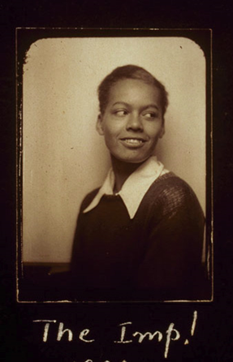
Pauli Murray knew that fighting against social injustices would upset the way things already were. They applied to the University of North Carolina’s graduate school, even though they did not accept people of color into their school. Franklin Porter, the University’s President, did not know what to do, so he asked the state Senate for advice. Murray was not accepted into the school, but many years later the University sent her an honorary degree that Murray did not accept. Pauli was arrested for rebelling against racist seating assignments on a bus to North Carolina while they were fighting to prevent the execution of Odell Walker, a black sharecropper who killed his white landlord in self-defense. Pauli got Franklin Roosevelt to write a letter in support of their application to their law school after graduating at the top of her class at Howard Law School, because they were upset with Harvard’s sexist rules. Murray spoke out about the sexism in the black radical movement and protested against the exclusion of issues that affected women of color in the feminist movement and the National Organization of Women. In “The Imp!” Murray poses for the camera grinning slyly over their shoulder as if content with her past actions and unafraid of their future.

Pauli Murray: The Dude
“Why do I prefer experimentation on the male side, instead of attempted adjustment as a normal woman?”
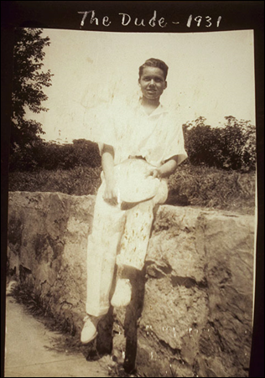
Pauli Murray was born Anna Pauline Murray. They renamed themself a more gender neutral, “Pauli,” during her young adult years. In the 1930s, Murray began talking to doctors about male hormone treatments. They discovered that doctors would only prescribe her female hormone treatments, but refused to take them. Murray recorded her life during this time in a photo album called “The Life and Times of an American Called Pauli Murray.” They took many pictures of themself and their partner Peggie Holmes traveling from Petersburg, Virginia to San Francisco. They also included many images in the album that demonstrate her physical agility. The image they entitled “The Dude” is among several others such as “Mike and Ike,” “Tennis,” and “The Vagabond” that express Murray’s masculinity and ability to do things that people considered not possible for women. Murray used the experiences of her male ancestors and family members to justify the different careers they chose as a civil servant, lawyer, author and priest, all careers that were dominated by men. Murray also fought for women’s rights and feminism; they were one of the first women to fight sex being a category in the 1964 Civil Rights Act. It is unclear how Murray would have identified today, but Murray believed in self-expression and that society should accept people for who they are.

Pauli Murray: The Crusader
“As a human being, I cannot allow myself to be fragmented into Negro at one time, woman at another, or worker at another. I must find a unifying principle in all these movements to which I can adhere…. This, it seems to me, is not only good politics but also may be the price of survival.”
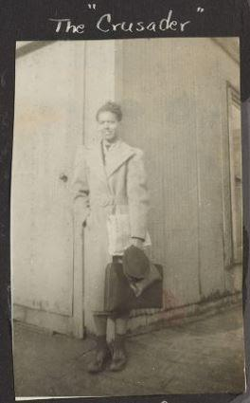
Pauli Murray graduated at the top of her class at Howard Law School, which should have gotten her a spot in Harvard’s Law School, but they were denied a spot because they were a woman. They went to California for school and became the state’s first woman of color to be the deputy attorney general. After Pauli returned to New York, they were the only female and African American lawyer hired by the law firm Paul, Weiss, Rifkin, Wharton, and Garrison. They became an advocate for addressing the connectedness of racial and gendered oppression. After the 1964 Civil Rights Act passed, Murray co-authored “Jane Crow and the Law: Sex discrimination and Title VII,” which used similarities between sex based discrimination with Jim Crow laws. Murray became the first African American to receive a JSD of Law degree from Yale University in 1965. The outfit and label Murray chose for the image “The Crusader” shows Murray in a suit, ready to complete tasks, while at the same time facing many challenges.

Pauli Murray: The Priest
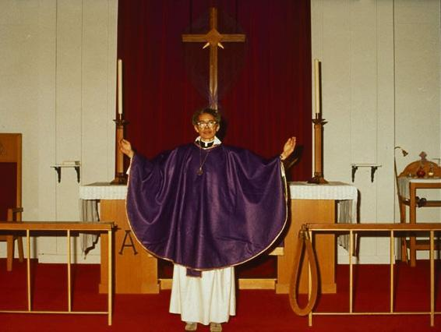
Considering her decision to move from law to priesthood, Murray stated her realization that, “race, sex, all the problems of human rights…were moral and spiritual problems” and that, “we had reached a point where law could not give us the answers.”

Pauli Murray was born to Agnes Fitzgerald and William Murray in Baltimore in 1910. Agnes Fitzgerald and William Murray were Episcopalians and had Murray baptized in their church, St. James’, which was the South’s first African American Episcopal Church run and operated by African Americans. They grew up attending St. Titus’ in Durham, North Carolina with her Aunt Pauline. By 1977, Pauli Murray became the first African American woman ordained an Episcopal priest. They offered their first Eucharist in the Chapel of the Cross in Chapel Hill, North Carolina which was the same church where her grandmother was baptized as a slave 123 years earlier. Murray served as pastor to two churches, the Church of Atonement in Washington D.C. and the Church of the Holy Nativity in Baltimore, Maryland before retiring at the age of 72.

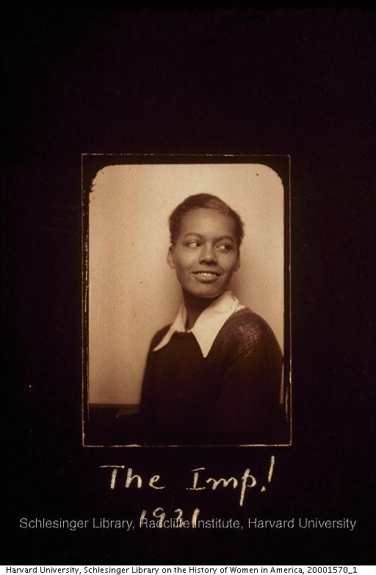

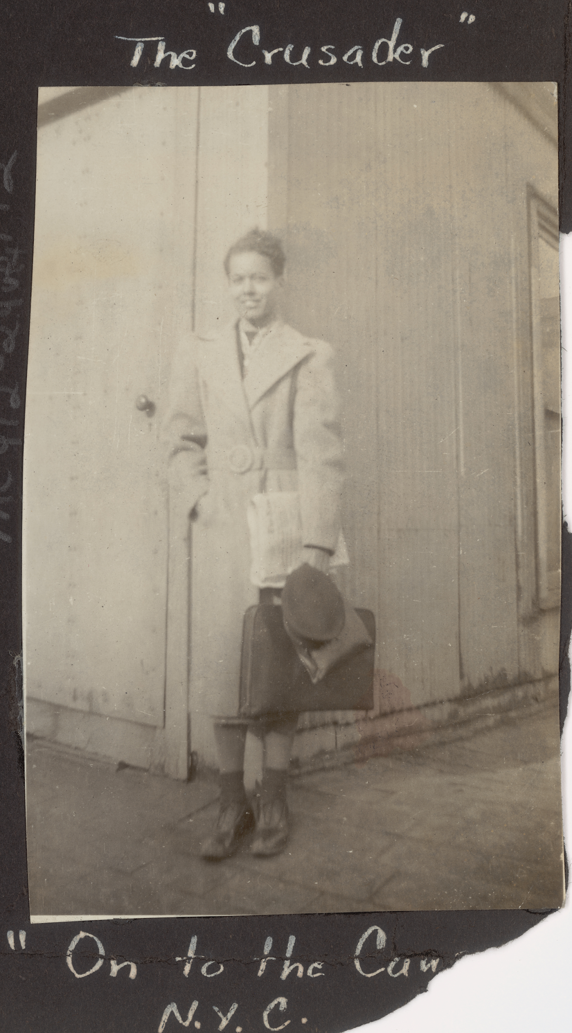
Photo courtesy of Schlesinger Library, Radcliffe Institute, Harvard University

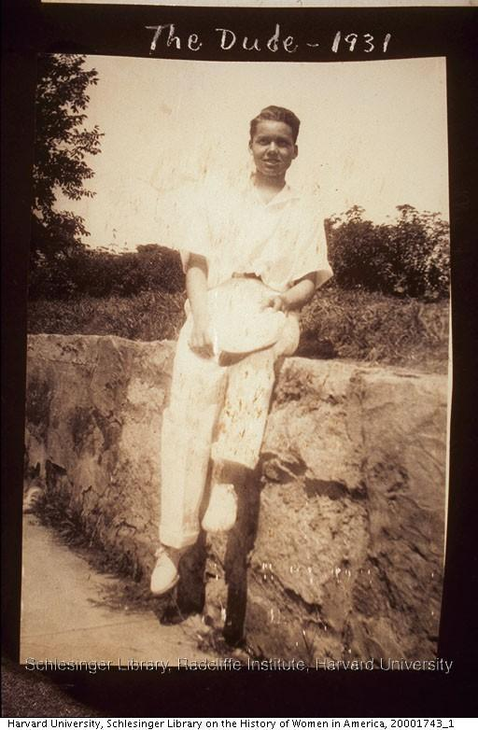

The Priest
Photo courtesy of Schlesinger Library, Radcliffe Institute, Harvard University

INTRODUCTORY LESSON PLANS

Activity 1: Web of Influence
Objectives/Goals: Introduce Pauli Murray and her spheres of influence, students consider their own spheres of influence and social capital, lay the groundwork for future research projects.
Time: 45-50 minute lesson w/homework
Themes: Social capital, spheres of influence, storytelling and characters, self-expression through different mediums (writing, visual aid creation, etc.)

Units: ELA 1, SS 6 (Possible to come back to later in year.)

Standards:
RL.8.6, 8.H.3.3, 8.H.1, 8.B.1

Materials/Handouts:
- Handout with Web of Influence (also online) http://prezi.com/vtixmqtqenzo/?utm_campaign=share&utm_medium=copy
- Resources for teachers explaining Murray’s relationships to people in the web including different achievements and setbacks related to different areas of their web of influence.
- Materials for students to create their own web of influence based on who they know who influences them and who those people know. This could be created online, with construction paper, or other materials so the class can continue to build their own web of influence throughout the year.

Description of Activity:
Display Pauli Murray’s web of influence, which includes figures from Betty Friedan to Martin Luther King Jr. to Malcolm X. Have students consider and discuss what they see on the web. Students will create their own web of influence including their family, friends, who they consider family, people from school, and can build branches based on the people one person in their web knows. The webs can include people they know personally and who inspires them that they may not know. Students will discuss the differences and similarities between their web and Pauli Murray’s web of influence including what area of Pauli Murray’s web they see people in their personal webs fitting into. Have them consider the ways that the people they know may have helped them through a hard time in their life.

Activity Steps:
- Display Pauli Murray’s Web of Influence from a handout or online resource
- Have students point out what they notice about the web and talk about any relationships they already know about between different people in the web.
- Talk about Murray’s social capital and relate who they knew to what they were able to achieve in their lifetime. Make sure to mention the different areas of connections they had including feminist, civil rights, family, educational and religious connections.
- Have them create either their own web and think about the different kinds of connections they have with others (religious communities, friends, school, family, etc.) or create a web for someone in their life whose story they do not want to see lost.
- Discuss the ways that these individuals provide a support network for the students when they are going through a challenge or hard spot.

- Extension Opportunity: Later in the year, have them do a research project and either create a web or do a research paper on a person they did not know in Pauli Murray’s web.
  - Students will include at least five other people that person was connected to and write about those connections and how they may have helped that person succeed.

Connections to Pauli Murray: This activity corresponds to the timeline of Murray, but from a bird’s eye view. It is another way to think about all that Murray achieved over their lifetime, but with the help of others.

Value and Skills:
- Build understanding of what impact people’s stories, including their own, have on others and the people around them.
- Ability to think critically about historical figures, how their social capital played a role in their achievements, and the choices they made based on their relationships.
- Have students consider their own power and social capital as a resource to them.
- Thinking creatively about ways they are connected to others and what this has to do with their identity. Creative self-expression.

Activity 1: Web of Influence Glossary

Online Resource: http://prezi.com/vtixmqtqenzo/?utm_campaign=share&utm_medium=copy

Civil Rights Sphere
Family Ties
Agnes Fitzgerald Murray-Pauli Murray’s mother. She was one of the first graduates from the Hampton Training School for Nurses. She passed away when Murray was three, but Murray remarked that she left an indelible impression on her.
Irene Barlow-Murray’s life partner. Barlow was the office manager at Paul, Weiss, Rifkin, Wharton, and Garrison, the law firm that Murray worked at in the early 1950s. She and Murray also shared a commitment to their Episcopal faith. During Murray’s stay there, she was the only woman and only African American on their staff of lawyers.
Cornelia Smith Fitzgerald- Pauli’s grandmother was the daughter of Harriet, an African and Cherokee enslaved woman, and Sidney Smith, a slaveholder from Chapel Hill. Murray spent her childhood in Cornelia’s house in Durham.
Robert George Fitzgerald- Murray’s grandfather served in the Union Navy and Army during the Civil War. After the war, he came to North Carolina to fight in the war against ignorance as a teacher and social activist. Later he convinced his Pennsylvania relatives to join him in uplifting the race in Durham.

Import Durham Activists and Historical Figures
Richard Burton Fitzgerald-One of Durham’s first African American business entrepreneurs, he started a brick making company in Chapel Hill. He became a public political leader in the city and founded the Mechanic and Farmer’s Bank. He was Pauli Murray’s great uncle.

Bayard Rustin- An organizer for civil rights, gay rights, non-violent protest. Rustin and Murray worked together to found the Congress for Racial Equality and Murray was also a member of the organization he worked for called the Fellowship of Reconciliation (FOR). FOR based its strategies on the non-violent protests that human rights activist Mahatma Gandhi pioneered in the Indian Independence movement to free India from British rule. Rustin and Murray both worked as organizers for the March on Washington for Jobs and Freedom.
Rev. Dr. Martin Luther King Jr.-Major figure in the struggle for black freedom during the era of the civil rights movement. He co-founded the Southern Christian Leadership Conference and has several famous speeches including his “I Have a Dream” and letters including “Letter from a Birmingham Jail.” Murray was both a supporter and critic of the male-dominated sphere of civil rights organizing.
Ella Baker-An early organizer in the civil rights movement and leader in the National Association for the Advancement of Colored People. While Baker was a staunch supporter of the NAACP, she was also a critic of the civil rights movement. She became a mentor to the leaders of the Student Non-violent Coordinating Committee (SNCC-pronounced “snick”) which was founded in Raleigh, NC. SNCC and the Congress of Racial Equality which Murray co-founded worked together to coordinate the famous freedom bus rides across the South. Later in her life, Baker campaigned for the release of Angela Davis, a black feminist activist, from prison.
Ralph Abernathy-Civil rights leader who co-founded the Southern Christian Leadership Conference. Abernathy became president of the organization after the assassination of Martin Luther King Jr. He served as an advisory committee member to the Congress for Racial Equality that Murray co-founded.
Dorothy Height-Leader of the National Council of Negro Women, civil rights organizer and planner of the March on Washington for Jobs and Freedom in 1963. After much protest from African American women, Dorothy Height was finally allowed to join the delegation that visited with President John F. Kennedy at the White House advocating for Negro civil rights. She was the only woman in the delegation. She and Murray became friends when they lived at the YWCA in New York in their twenties.
Maida Springer-Labor activist and long-time friend of Murray. Both women worked to raise awareness about the lack of women’s representation in government by running for public office. When Murray ran for city council in Brooklyn’s Tenth Senatorial District in 1949, Springer was her campaign manager. In Murray’s final years, she and Maida lived in a side by side duplex in Pittsburgh where Maida family helped support them.

Civic Leaders Sphere
Eleanor Roosevelt-women’s rights and human rights activist. First lady while Franklin Delano Roosevelt held office from 1933-1945. Murray wrote Franklin Roosevelt to advocate that he take a stronger stance on issues related to race and inequality. Mrs. Roosevelt responded to her letter and thus began their political relationship and friendship.
Donna Shalala-Feminist activist, professor, and college president. She served as the Secretary of Health and Human Services under President Bill Clinton (1993-2001). Pauli Murray inspired Shalala in her efforts to pursue her political career. Shalala wrote that Murray’s “words and life have been an inspiration for all of us.”

Mary Pauline Fitzgerald Dame-Murray’s Aunt Pauline raised her after the death of her mother Agnes when Murray was three years old. Pauline was a schoolteacher in Durham who organized for women’s and African American’s right to vote. She often carried out this work in her classroom by instilling a sense of self-respect and dignity in her students. She co-founded the Volkamania Literary Club with her sister Sallie Fitzgerald which brought African American women together to debate contemporary issues.
Lewis E. Austin- Editor of Durham’s African American Newspaper, The Carolina Times, from 1927-1971. Murray started out as a paper delivery girl when she was in elementary school and continued the work through high school. Later in life, Austin supported Murray by publishing pieces in the Carolina Times about her efforts to get into UNC Chapel Hill.
Mary Lee Fisher Morris and Minnie Pearson Turner Spaulding-co-founders of the Durham Chapter of the Delta Sigma Theta Sorority, Inc. Both women taught at Hillside High. Spaulding was an older student who mentored Murray and Morris was a teacher who encouraged Murray to write.

Feminist Sphere
Betty Friedan-Feminist activist, theorist, and author of The Feminine Mystique. Friedan and Murray worked together on women’s rights and co-founded the National Organization of Women together with other women’s rights activists.
Thelma Stevens- A leader in the Women’s Missionary Council for the Methodist Episcopal Church. The Women’s Council commissioned Pauli Murray to research laws related to race and color. From that research came the 1951 book, States Laws on Race and Color, named the bible for civil rights lawyers by Thurgood Marshall. Here, Stevens and Murray review the book together.
Thurgood Marshall-Associate Justice on the U.S. Supreme Court (1967-1991) He was the lead attorney for the NAACP in the Brown vs. Board of Education decision that desegregated public schools. Pauli Murray wrote States Laws on Race and Color that he and civil rights lawyers used as a resource to fight segregation. He called her book, the “Bible” of civil rights lawyers.
Patricia Roberts Harris-the first African American woman to serve in the U.S. Cabinet. She became the United States Secretary of Housing and Urban Development (1977-1979), and United States Secretary of Health, Education, and Welfare (1979-1981). She met Pauli Murray at Howard Law School. Murray became a friend and mentor to Harris who was few years younger than Murray and one of the few African American women there in addition to Murray.

Authors and Writers Sphere
Ted Poston-Influential reporter from Harlem. He had his own byline in the Pittsburgh Courier and was an activist in fighting racial discrimination through his writing. He met Murray when she lived in Harlem and he encouraged her writing career.
Countee Cullen-Poet in the Harlem Renaissance who inspired Murray. She met and was friends with Cullen while she lived in Harlem. He gave her a practical picture of what a struggle his life as a writer had been like when she began working on Dark Testament, her famous poem on racial inequalities during the 1940s.
Langston Hughes-Poet and leader of the Harlem Renaissance. Hughes’s poetry concerning African American life inspired Murray’s poetry. Murray knew Hughes and his work inspired her famous long poem called Dark Testament.
Lillian Smith-Publisher and owner of the journal South Today. The journal was based in Georgia and published issues relevant to women’s rights and civil rights. Editor Smith and her partner Paula Snelling supported Murray by being the first to publish Murray’s poem Dark Testament in 1943. They became friends and wrote many letters to each other over the course of their lives.

Activity 2-Living Timeline
Objectives/Goals: Recreate a timeline of Pauli Murray’s life to help students think critically about the different historical moments Murray was a part of, the challenges they faced, and what she achieved. Building critical thinking skills related to narrative and history. Working creatively as a team, students will decipher what events built Murray’s timeline.
Time: 45-50 minute lesson
Themes: Timelines and social movements, understanding set-backs and challenges in history, narrative, historical events that build historical movements.
Units: ELA 1, SS 6 (Possible to come back to later in year.)
Standards: RL.8.2, W.8.3, 8.H.1.1, 8.C&G.2.1, 8.C&G.2.2
Materials/Handouts:
- Pauli Murray Timeline for teachers (found below)
- Suggested break down of events in Murray’s life without dates
- Brackets with dates that events can fit into
- Art materials:
  - Paper
  - Markers
  - Scissors

Description of Activity:
As a class, recreate Pauli Murray’s timeline. Create images associated with different events in her life without using the dates. Have the students try to decide where each event goes without dates attached to the events as a way to review parts of Murray’s life. Once students negotiate the order of events in Murray’s life with associated dates, each group can take a section or different groups can take a section and later present it to the class. Have students discuss the many different turns, setbacks, challenges, and achievements Murray encountered in their lifetime. Ask students what they notice about the different sides of her careers and identities that made Murray who they were over time. Have students think, discuss, or do a short writing activity about a challenge they have faced that a part of Murray’s timeline reminded them of including what ways they overcame that challenge. This timeline can be placed in the classroom or hallway. When students have finished, they can add their own experiences/knowledge to places and dates on Murray’s timeline as a way for students to consider how the places and times Murray occupied live on in different ways.
The Hook: Have students pick five important events in their lives. Have them write down the location of the event, a little bit about what was surrounding that event, and what they remember about it. Have them choose one of those events and share with a small group what they guess what else might have been going on around then during that time.

Activity Steps:
- Break up sections of timeline for students without dates associated
- Create framework with dates that students can plug their events into
- Have each group talk with each other about the moments of her timeline and try to place them where they belong
- Discuss findings and what they noticed about Pauli Murray’s life, challenges, and the changes that Murray went through throughout their life. How did Pauli Murray show resiliency in the face of challenges?
- Have students think about a challenge they have faced in their lives that may be similar to a challenge that Murray faced and how they overcame that challenge. Discuss in small groups or have students do a short writing exercise about the experience.
- Timeline could be placed in hallway or around top of classroom.

- Extension Opportunity : For a project later in the year, students could create a complementary timeline on what was happening in Durham, North Carolina, and the U.S. throughout Murray’s life based on research. Consider how Murray may have been in another place but how her relatives and North Carolina community continued to fight for civil rights. They can also relate their own personal experiences they have had in Durham to the places that Murray occupied earlier in their life.

Value and Skills:
- Teamwork and communication skills
- Verbalizing ideas, inferences, and rationale
- Greater understanding of historical moments Murray was a part of and places they occupied
- Building awareness of themselves as located in historical moments
- Identify moments of resiliency in their own lives

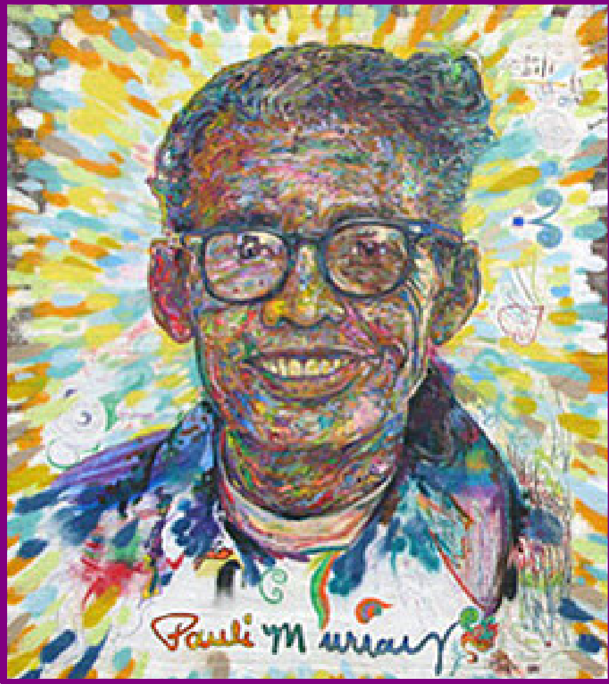

Meet
Pauli Murray

Activist, Poet, Lawyer, Priest
A life of reflection and action

Nov. 20, 1910- Pauli Murray was born in Baltimore, Maryland to Agnes Fitzgerald and William Murray.

1914 - Pauli Murray moves to Durham to live with her aunt, Pauline Fitzgerald Dame, after whom s/he was named. Pauli’s mother had died of a cerebral hemorrhage and her father was unable to care for their six children.

1923 - William Murray is murdered at Crownsville State Hospital by a guard.

1926 - Pauli graduates from Hillside High with a certificate of distinction. They received another high school diploma from Richmond Hills High School in New York in 1927 so that S/he could meet entrance requirements at Hunter College.

1933 - S/he graduates from Hunter College and goes to work for the Works Project Admission (WPA), Workers Defense League and as a teacher in the NYC Remedial Reading Project.

1937 – Pauli seeks gender-affirming medical treatment, including hormone therapy.

1938 - S/he attempts to gain admission as a graduate student at the University of North Carolina at Chapel Hill. S/he is rejected because of her race. While the NAACP supports Murray in challenging the school’s segregationist policies, they decide not to pursue the case for many reasons. Her letter writing campaign, however, brings her to the attention of First Lady Eleanor Roosevelt. They begin a lasting friendship.

1940 - Pauli joins the Fellowship of Reconciliation. While traveling to Durham, S/he is arrested and jailed for protesting Virginia law requiring segregation on buses.
S/he refused to sit on broken seats at the back of the bus. S/he then returns to Virginia to raise money for legal fees for Odell Waller, a black sharecropper accused of murder.

1941 - S/he enters Howard Law School and encounters overt sex discrimination from faculty and students.

1942 - Odell Waller is executed. Murray writes a letter to President Franklin D. Roosevelt on behalf of outraged leaders. S/he criticizes the presidents’ failure to improve conditions for black southerners.

1943 - Murray publishes “Negroes are Fed Up” in Common Sense and an article about the Harlem race riot in the socialist newspaper New York Call. S/he also publishes her famous poem on race relations, “Dark Testament,” in the winter issue of South Today, a magazine published by Lillian Smith and highly regarded for its literary entries and attention to southern racial issues.

1944 - Pauli Murray and fellow students from Howard University take part in a silent demonstration and sit-ins
at a Washington D.C. cafeteria. The students are eventually served, however, the president of Howard orders them to suspend further demonstrations.

1944 - Pauli Murray graduates from Howard Law School first in her class (and the only non-cisgender man). S/he wins a prestigious fellowship and applies to Harvard Law. S/he is rejected because of her gender despite having President Roosevelt (an alumni of Harvard) write a letter to the president of the university on her behalf. S/he enrolls at University of California’s Boalt Hall Law School to work on a graduate degree in law.

1945 – S/he received a Masters of Law degree (L.L.M.) from University of California, Berkeley. Her master’s thesis is entitled, “The Right to Equal Opportunity in Employment.” S/he passes the California state bar.

1945 – Pauli Murray’s aunt Pauline retires after teaching for 60 years and moves to NYC to live with her.
1947 – Pauli Murray is named “Merit Award Winner” by Mademoiselle magazine for her legal work against race and gender discrimination.

1948 – Murray runs for and receives the fourth highest vote total in the New York City council race for Brooklyn’s tenth Senatorial district, barely missing being elected.

1951 – Murray writes the States’ Laws on Race and Color for the Women’s Division of the Methodist Church, which is labeled the “bible” by Thurgood Marshall and other civil rights lawyers.

1952 – Murray is a victim of McCarthyism. S/he is rejected for a US State Department position administered at Cornell University because the people who supplied her references, Eleanor Roosevelt, Thurgood Marshall and A. Phillip Randolph, are considered to be too radical.

1955 - Pauli Murray’s Aunt Pauline dies. On her deathbed, Pauli reads to her from the Book of Common Prayer.

1956 – Pauli Murray’s seminal work Proud Shoes: The Story of an American Family, a biography of her grandparents, their struggles with racial prejudice and early Durham history is published.

1956 – S/he is the only non-cisgender man hired by the NY firm of Paul, Weiss, Rifkin, Wharton, and Garrison.

1960 – Murray travels to Ghana and takes a position as a senior lecturer at the Ghana School of Law in Accra.

1961 - John F. Kennedy appoints Murray to the President’s Commission on the Status of Women Committee (PCSW) on Civil and Political rights. Works with A. Phillip Randolph, Bayard Rustin and Martin L. King, Jr. on civil rights.

1964 – US Civil Rights Act passed. Murray co-authors “Jane Crow and the Law: Sex discrimination and Title VII,” in which S/he draws parallels between sex-based discrimination with Jim Crow laws.

1965 – Murray receives a J.S.D from Yale, the first African-American to receive this doctoral level law degree. Her dissertation was entitled, “Roots of the Racial Crisis: Prologue to Policy.”

1965-1973 – Murray serves on the National Board of Directors for the American Civil Liberties Union (ACLU).

1965-66 - Murray serves as co-counsel in White v. Crook, which successfully eliminates the use of sex and race discrimination in jury selection.

1966 - Along with Betty Friedan and thirty others, Murray is a founding member of National Organization for Women (NOW).

1967 – Murray serves as vice-president of Benedict College in Columbia, SC.

1968-1973 – Murray is tenured as Professor of Law and Politics at Brandeis University.

1973 – At age 62, Murray entered General Theological Seminary prior to the Episcopal Church’s approval of women as candidates for ordination and in 1976 S/he completed the Master of Divinity degree.

December 8, 1977 – Pauli Murray becomes the first African-American person perceived as a woman to be ordained by the Protestant Episcopal Church. S/he offered the Eucharist for the first time on February 13 at Chapel of the Cross, Chapel Hill, NC where her grandmother Cornelia was baptized as an enslaved person.

1982 – Murray is forced to retire because Episcopal Church law requires retirement at age seventy-two.

July 1, 1985 – Pauli Murray dies in Pittsburgh, PA.

1987 – Pauli Murray’s autobiography Song in a Weary Throat: An American Pilgrimage is published.

2011- N.C. Department of Archives and History installs a state highway historic marker honoring Pauli Murray ¼ mile north of her childhood home in Durham.

2012 – Reverend Dr. Pauli Murray is elevated to the status of sainthood by her inclusion in the Book of Holy Women, Holy Men by the General Convention of the Episcopal Church.

2015 – Pauli Murray Family Home Named National Treasure by the Natl. Trust for Historic Preservation.

2016 - Pauli Murray Family Home Named National Historic Landmark by the National Park Service.

Selected Bibliography:
Murray, Pauli Dark Testament and Other Poems. Norwalk,
CT: Silvermine, 1970.
____. Proud Shoes: The Story of an American Family. New York: Harper & Row, 1978.
____. Song in a Weary Throat: An American Pilgrimage. New
York: Harper & Row, 1987. [Reissued, Pauli Murray: The Autobiography of a Black Activist, Feminist, Lawyer, Priest, and Poet. University of Tennessee Press, 1989.
____. States Laws on Race and Color. Cincinnati: Women’s Division of Christian Service, Board of Missions and Church Extension, Methodist Church, 1951.

Azaransky, Sarah. The Dream is Freedom: Pauli Murray and American Democratic Faith. New York: Oxford University Press, 2011.

Bell-Scott, Patricia. The Firebrand and the First Lady: Portrait of a Friendship: Pauli Murray and Eleanor Roosevelt, NY: Random House, 2016

Rosenberg, Rosalind. Jane Crow: The Life of Pauli Murray. New York: Oxford University Press, 2017

Activity 3-Pauli Murray’s Activism Through Words
Objectives/Goals: Be able to answer the question, “How does an author create a mood or affect for the reader with different techniques?” and “How do authors use techniques like suspense, humor, or mystery?” Have an understanding that some texts are concrete and deal literally with a topic while others are stories meant to make a point about a more universal experience. Writers write to reflect on what they have learned from experience.
Time: 45-50 minute lesson
Themes: Primary Sources, main message, supporting details, why humans tell their stories, identity formation, rhetorical savvy, 20th Century social movements.

Materials/Handouts:
- Worksheet with excerpts from primary sources (Proud Shoes, Song in a Weary Throat, transcript of oral history interview) and related questions.
- Oral history clip online for students to listen to
- Discussion questions once students fill out their worksheets

Description of Activity:
Invite students to read two passages, one from Pauli Murray’s book Proud Shoes and one from her long poem Dark Testament. They can read them aloud to a small group or to themselves and fill out worksheets. Have students listen to a clip of Murray’s Oral History describing a stumbling block Murray encountered when UNC did not admit her because of her race. Use discussion guide to allow students to process the clip in a jigsaw model (in a group of four, each person takes a question and then the group discusses their answers.) Each passage is from a different era of her life. If you would like, compare and contrast the passages as a class.
The Hook: Introduce three pieces of text or a speech that deeply affected you as the teacher. Have students brainstorm 3 pieces of text (phrases, quotes, songs, speeches, book, etc.) that deeply affects them. Have them explain why either through free writing or a class discussion. What place does that piece of text have in their lives?

Units: ELA 1, SS 6 (Possible to come back to later in year.)

Standards:
RL. 8.2, RL.8.6, 8.H.2.2, 8.H.2.3, 8.H.1.3, RH.6-8.1, RH.6-8.4

Value and Skills:
- Reading comprehension
- Ability to identify and work with various primary sources
- Ability to see connections and contrasts between primary sources

Activity Steps:

- Allow students to read passages and fill out the primary source worksheets to identify the main message and supporting details.
- For the Oral History Clip Activity, find online at https://soundcloud.com/pauli-murray-project/pauli-murray-denied-entry-to-unc. Pass out worksheet and play the oral history clip. Let students know before they listen that UNC did not allow African Americans to attend UNC when Murray tried to apply. (UNC did not admit African American students until 1951. Harvey Beech, J. Kenneth Lee, Floyd McKissick and James Robert Walker Jr. were the first African American students admitted to UNC’s law school.) Students can answer all the questions or choose one that they will report on to the group. They will decide which questions they will answer before listening and use their worksheet while they listen. After listening to the clip and filling out their questions, they can discuss in small groups the answers they wrote for their question. The last question (#5) is meant to be discussed as a small group.
- If you would like to tie all of these passages together, discuss each passage by comparing and contrasting what they notice about tone, word choice, bias and descriptive elements in each passage.

Activity 3: Pauli Murray’s Activism through Words
Excerpt from “Proud Shoes: Story of an American Family” by Pauli Murray

Directions: This passage describes Murray’s reaction to finding out that some of her ancestors endured slavery. This passage was taken from page 62 of Proud Shoes. Read the passage once thoroughly and then go back through when you need to as you answer the questions on the worksheet.

“As I moved back painfully through memories of my own childhood and peeled off the layers of pride which had encrusted me, I came to see how those who have been crippled by damaging experiences seize hold of any crutch to help themselves along. I realized we are as anxious to hide our spiritual scars as our physical disfigurements. Slavery had done such violence to the human spirit that the very memory of it was intolerable long after people had outlived it. Even in my time many were trying to grow without roots at all, plucking their sustenance from the air about them. We, Fitzgeralds, had choked off part of our roots and hidden our deep scars beneath a lopsided pride.

It was just as well I had not stumbled upon Great-Grandfather Thomas’ secret until now. I lived too close to the blight of the slavery past when I was a child, and there were no vaccines to protect me. It was still too threatening and the future too uncertain to risk looking backward with critical eyes. It was only as an adult living in the shrunken world of the mid-twentieth century and from the vantage point of present-day knowledge of human experience that I could now see a fragment of personal history in proper perspective. It had taken me almost a lifetime to discover that true emancipation lies in the acceptance of the whole past, in deriving strength from all my roots, in facing up to the degradation as well as the dignity of my ancestors.

Great–Grandfather Thomas’ own life had contributed greatly to this realization, but he did not have this century of accumulated experience to draw upon. He had grown up during a period in which ignorance and cruelty were more common than learning and humaneness. Few people could read and write in his time and the only local journal in his state was the Delaware Gazette, which came out once a week. Dueling and random gun fights were frequent in the Wilmington streets and petty offenses were punished by the stocks, pillory and public whipping post, the last surviving in Delaware to the present day. Travel was perilous and when someone contemplated a trip to Philadelphia, twenty-six miles away, all his friends and relatives came to see him the night before the stagecoach left to bid him farewell and wish him a safe journey.”

“Proud Shoes” Passage Questions:

- This passage is about Murray’s reaction to the history of slavery in her family. Read the first paragraph again.
  - What does the word sustenance mean in the sentence “many were trying to grow without roots at all, plucking their sustenance from the air about them”?
________________________________________________________________________________________________________________________________________________
  - What does this sentence mean for Murray?: “Even in my time many were trying to grow without roots at all, plucking their sustenance from the air about them.”
______________________________________________________________________________________________________________________________________________
- Read the second paragraph again and read the last sentence carefully.
  - What gives Murray “true emancipation”?
________________________________________________________________________________________________________________________________________________
  - Murray states that they can “derive strength from all my roots”. Explain what you think this means for Murray.
________________________________________________________________________________________________________________________________________________
- In the last paragraph, Murray explains the circumstances their Great-Grandfather Thomas experienced. What is an aspect of life that surprised you from the time during which he lived?
________________________________________________________________________________________________________________________________________________
- What lessons do you think this passage holds for people today? Can they learn anything from the way that Murray talks about their past and future?
________________________________________________________________________________________________________________________________________________
________________________________________________________________________
Excerpt from “Dark Testament”
A Poem by Pauli Murray

Directions: Read this poem and answer questions below.
Dark Testament: Verse 8

Hope is a crushed stalk
Between clenched fingers
Hope is a bird’s wing
Broken by a stone.
Hope is a word in a tuneless ditty —
A word whispered with the wind,
A dream of forty acres and a mule,
A cabin of one’s own and a moment to rest,
A name and place for one’s children
And children’s children at last . . .
Hope is a song in a weary throat.
Give me a song of hope
And a world where I can sing it.
Give me a song of faith
And a people to believe in it.
Give me a song of kindliness
And a country where I can live it.
Give me a song of hope and love
And a brown girl’s heart to hear it.

Questions about “Dark Testament”:
- What does this poem say about hope? What are the different tones Murray uses to express her ideas about hope in the poem?
______________________________________________________________________________________________________________________________________________________
- What impact does the last line have for people who might read this poem today? What images and feelings come to mind when you read this last line?
_____________________________________________________________________________________________________________________________________________________
Excerpt from Pauli Murray’s Oral History Clip
Denied Entry from UNC

Directions: Use this transcript to read along as you listen to the Oral History Clip about Pauli Murray’s efforts to get into UNC Chapel Hill during a time that UNC did not admit African Americans. Complete the worksheet after you listen to the clip. Feel free to underline sections that have to do with your questions as you listen so you can go back later and answer the question!

Interview with Pauli Murray by Genna Rae McNeil, 13 February 1976 (G-0044), in the Southern Oral History Program Collection (#4007), Southern Historical Collection, Wilson Library, University of North Carolina at Chapel Hill.

Listen to the Clip (8 minutes and 48 seconds): Found at https://soundcloud.com/pauli-murray-project/pauli-murray-denied-entry-to-unc.

Interview Transcript:

PAULI MURRAY:
I think the key fact, the thing that made me really apply to the University of North Carolina ‚well, here again was a convergence of factors, my ostensible reason, and it always seemed to be this way, that I had some family problem, some personal problem that I was trying to work out and what seemed very logical to me, I then began to follow up on. Of course, the minute that I began to follow up on what was very logical to me, I began to run into road blocks. My aunt really wanted me to come home.
GENNA RAE MCNEIL [Graduate student and now professor of History at UNC-Chapel Hill]:
This is Aunt Pauline?
PAULI MURRAY:
Aunt Pauline and Aunt Sally, Now, they were getting older and my problem was that I wanted to get some more education. I wanted to do some graduate work. Well, wouldn't it make great sense to come home and commute to the University of North Carolina and get a graduate degree at the University of North Carolina, either in social science or in law and that would allow me to fulfill my family responsibilities in Durham.
GENNA RAE MCNEIL:
We find that after the futile attempt of Thomas Hocutt under the auspices of the NAACP to enter UNC School of Pharmacy, Pauli Murray, because of a number of reasons, which you stated, some having to do with family, sees it as a logical thing to do to enter UNC in social science or law school. So, in November of 1938, you apply for a catalog and an application and thereafter, what occurs?
PAULI MURRAY:
They sent me an application blank and they had written into the printed application blank, race and religion. This has been typed in so that it stands out apart from a normal form. I think I answered it but may have said, "But what difference does it make?" Obviously tongue in cheek. In due course, I got back a letter from Dr. Frank Graham, who was the then president of the University of North Carolina, saying, "I'm sorry, but the constitution and the laws of the state of North Carolina prohibit me from admitting one of your race to the law school." Either the day after or two days after I received this letter, down came the Supreme Court decision in the Lloyd Gaines case. Now, the Lloyd Gaines case decided in December of 1938 was the beginning of the long road back from Plessey vs. Ferguson, the "separate but equal" decision. Lloyd Gaines, in the educational field, was the start of the long road back to the 1954 decision and what it said was: A state has a responsibility to educate its residents. It cannot shift responsibility to other states by giving out-of-state scholarships. It must give substantially equal facilities to its colored citizens as well as the white or must admit them to the existing institutions. It went on to say that this is a "personal right" and in a sense it does not matter if only one person is seeking it. This, of course, you can imagine, I immediately wrote back to the University of North Carolina and said, "Ah, but here is the Lloyd Gaines case." The story is that, the legend is that Dr. Frank Graham sent my application down to the legislature. Remember that this is now December. The legislature meets around January 5, 1939 something of the sort and says, "Look, what are we going to do with this? Here's the Lloyd Gaines case and here's this application." Presumably, it was the bouncing of the application down to the legislature and the problems that this raised for the legislature, "Look, we can't fool around with this, the issue is upon us," that made it newsworthy and it must have leaked up in that way, because I knew nothing about it and my family knew nothing. I don't even know if I had, maybe I had told my family. I guess that I had.
GENNA RAE MCNEIL:
Since their house was about to be burned, perhaps, you probably mentioned to them. [laughter]
PAULI MURRAY:
And it suddenly burst out over the radio, you know, and came to be sort of national news. But it was this "unidentified Negress." [laughter] It's in the headlines, an "unidentified Negress makes application to the University of North Carolina." This correspondence went back and forth for awhile and then I put the whole stuff together in an envelope and sent it down to the NAACP, namely to Thurgood Marshall, maybe I sent it to Walter White and he referred it to Marshall. Well then to take the cake, I thought, "All right, they couldn't win on Hocutt because of complications and whatnot, but nobody can say anything about the standing and status of Hunter College nor of me in terms of academic standing, and isn't this an answer?" I then got the shock of my life. I learned that the NAACP very carefully picks its cases in these days, they had to win every case, it goes carefully into the background of the person who is going to be the bearer of the case, and all of this being said to a proud Fitzgerald Murray, you know, "What does he mean by, going carefully into the background of it?"‚ But there was a certain kind of, the way that I read this was, "We have to be very careful of the people that we select. They have to be Simon-pure and you are not quite Simon-pure enough." I was too maverick.

Discussion Questions for Oral History Clip about UNC
Denying Murray Based on Her Race:

- Why did Pauli Murray want to apply to attend UNC Chapel Hill as a graduate student?
________________________________________________________________________________________________________________________________________________
________________________________________________________________________
- When Murray received a blank application, what did they find that the UNC administration had added into the application? What did you think of the way she answered those questions?
________________________________________________________________________
________________________________________________________________________
________________________________________________________________________
- What did Dr. Frank Porter Graham, the president of UNC do when he received Pauli Murray’s application? What effect did his actions have on the media attention their application received?
________________________________________________________________________
________________________________________________________________________
________________________________________________________________________
- What do you think Murray meant in the last sentence of the clip when she says she was “too maverick”? Do you think it was fair that the NAACP did not choose Murray’s case to bring to court? Why might they have made that decision?
________________________________________________________________________
________________________________________________________________________
________________________________________________________________________________________________________________________________________________________________________________________________________________________
- As a group, discuss where you see bias occurring in this clip? Who expressed bias and what does their bias show you about their stance? There are many places in which bias appears, so discussing more than one section is ok! Write down notes on your discussion here:
________________________________________________________________________
________________________________________________________________________

EXPRESSING OURSELVES LESSON PLANS

Activity 1-Telling Your Story Is Activism
Objectives/Goals: Empower students to think about the importance of their own stories. Set students up to identify elements of their story that might be compelling to others including linking to visual representations of their stories. Have students continue to reflect about challenges students have faced and how they showed resiliency in the face of that challenge.
Time: 45-50 minute lesson
Units: ELA 1, SS 6 (Possible to come back to later in year.)
Standards: W.8.3, RL.8.6, 8.H.2.2, 8.H.2.3, 8.H.1.3
Materials/Handouts:
- Pauli Murray timeline to review her life challenges if needed
- Materials for students to create representations of their stories through writing and visual representation including some of the following:
  - Story strip with four boxes for students to fill if they elect to create a comic strip
  - Cameras for a photography project
  - Painting or drawing materials
  - Paper or computer to write captions or story
Description of Activity:
Have students create representations of their stories through written narrative with visual components or visually with titles and captions. Their stories can be created through a photography project, comic strip, written story, video project all relating to a challenge they have faced and made decisions about what to do in the face of that challenge. Students can think about telling their story, like Murray, as a form of activism so that others can grow and learn from their stories.

Activity Steps:
- Review what connections students made between the importance of sharing Murray’s story including challenges and triumphs
- Have students select a way they would like to tell or document their own story as a form of sharing what they have learned in life with others.
- Students can develop their story through written narrative or visual representation, but have them consider either a visual component to their story or captions and titles to their visual or documentary project.

Value and Skills:
- Informational writing skills including understanding their writing as activism.
- Creative writing as a way to synthesize information
- Identify what makes a story compelling and consideration of audience
- Application of concepts from one form of self expression to another

Activity 2: Justice Now
Time: 2-3 days
Materials/Handouts:
Pauli Murray Timeline (found in earlier lesson materials)
Sample Article Murray wrote about Housing Discrimination in California (located in 8th Grade Activity Resource Section).
Poem from Dark Testament.

Objectives/Goals: Be able to answer the question, “How do my audience and purpose influence the way I write?” and “What makes a good story?” Have an understanding that some texts are concrete and deal literally with a topic. Others are stories meant to make a point about a more universal experience. The words an author chooses indicates the way he/she feels about a subject. The organizational structure of a text impacts its effectiveness.
Units: ELA Unit 1, 2; SS 6 (Possible to come back to later in year.)
Standards:
W.8.3, RL.8.2, W.8.1, 8.H.2.2, 8.H.2.3
Skills: Self-expression, communication of ideas, assessment of audience, critical thinking about historical moments and trajectory into today, critical thinking about current events and the world they live in, development of strategies for self-advocacy and standing for their beliefs.

The Hook: Give students time to think about what issues Pauli Murray tackled in her lifetime as a class. Have them write down which issues they think are still relevant and why. Let them free-write about why they think that issue is still important today.
Description of Activity:
Students will consider what issues Pauli Murray tackled in her lifetime and whether they are still relevant today. Thinking about the ways that Pauli Murray advocated for what they thought was right, students will think about what they would do today to address an issue they still find relevant.

After selecting a medium to express themselves about an issue (racism, selfishness, poverty, LGBTQ rights, sexism, classism, etc.) they will create a piece that speaks out against that issue or suggests solutions. This could be through a letter to a government official, blog post, justice-inspired visual art, website, poem, rap, etc.

Themes: Activism and advocacy, communicating ideas in compelling and clear manner, considering audience, how to build argument using logic.

Activity Steps:
- Review Pauli Murray Timeline and issues that Pauli Murray tackled. Ask students how they saw Pauli Murray addressing certain issues. How did she go about it?
- Allow students to select what issue they think is still relevant today that is most important to them.
- Review some of Pauli Murray’s poems and articles to explore what elements of those written forms of activism were most compelling.
- In small groups, have students share why they think that their issue is still relevant today. Other students who are listening can write down persuasive points or good points they notice the other person saying and share with them. This will help the students develop their points.
- Students will take time to decide how best to express what they think about a social justice issue today. This could take the form of:

  - Public art piece
  - Performance
  - Song
  - Blog post
  - Letter to representative
  - Poem
  - Website
  - Resource pamphlet
  - Zine
  - Graffiti
- Allow students to go through draft processes and peer review.
- Invite students to create and present their advocacy pieces.
Poem from Dark Testament and Other Poems by Pauli Murray
Prophecy:
Listen to the Poem: http://paulimurrayproject.org/pauli-murray/poetry-by-pauli-murray/

I sing of a new American
Separate from all others,
Yet enlarged and diminished by all others.
I am the child of kings and serfs, freemen and slaves,
Having neither superiors nor inferiors,
Progeny of all colors, all cultures, all systems, all beliefs.
I have been enslaved, yet my spirit is unbound.
I have been cast aside, but I sparkle in the darkness.
I have been slain but live on in the river of history.
I seek no conquest, no wealth, no power, no revenge:
I seek only discovery
Of the illimitable heights and depths of my own being.
Cambridge, 1969

Activity 5: Justice Now
Article about racist housing discrimination Murray faced in California written by Pauli Murray.
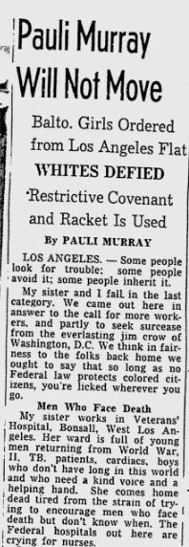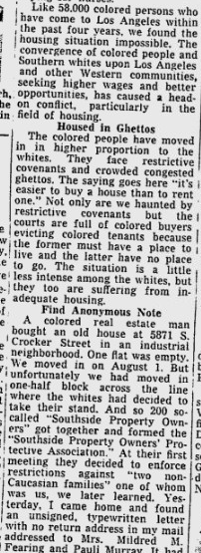

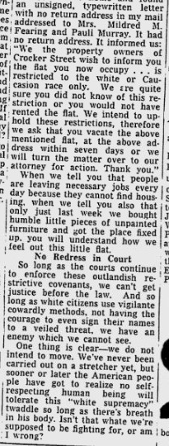

Activity 3-The Power of Spoken Self Expression
Objectives/Goals: Be able to answer the question, “How do authors use technique to create suspense, humor, or mystery?” and “How does an author create a mood or affect for the reader with different techniques?” Have an understanding that some texts are concrete and deal literally with a topic. Others are stories meant to make a point about a more universal experience.
Time: 45-50 minute lesson
Themes: Critical thinking about non-prose sources, placing art in historical context, extraction of themes from non-prose self-expression, application to different contexts.
Units: ELA 1, SS 6 (Possible to come back to later in year.)
Standards:RL.8.2, W.8.3, 8.C&G.2.1, 8.C&G.2.2, 8.H.2.3

Materials/Handouts:
- Several poems from the Dark Testament for teachers to choose from
- Information about Dark Testament and when Pauli Murray wrote the book
- Spoken word piece (lyrics, rationale, and annotated versions) written about Pauli Murray by Brandon Hudson Online version: https://soundcloud.com/namuhstay/americas-problem-child

Description of Activity:
Have students read and discuss a poem from the Dark Testament. Discuss the different elements and themes of the poem. Have them write their own poems/rap/song about related themes based on their own lives through the following breakdown. This activity could be used later in the year.

Activity Steps:
- Read poem aloud or have students read poem and discuss in small groups
- Discuss the themes in the poem, have students think about how the themes could be relevant to their lives and current events.
- Mention some of the circumstances in which Pauli Murray wrote this poem. They wrote it a few years after they were denied entry to UNC because they were African American, very soon after a sharecropper who she was fighting to get off death row named Odell Waller was executed, and a year before she graduates at the top of her Law class at Howard University and begins fighting to get into Harvard’s law school which she was later barred from due to the fact that she was a woman.
- Review elements of poems and what kinds of poems or spoken word pieces they can write. Share example written by Brandon Hudson, spoken word artist of Durham.
- Invite students to write their own poem/song/rap about the themes relevant to their lives.

Value and Skills:
- Reading comprehension with non-prose writing forms
- Creative self expression and oral presentation
- Gaining historical literacy and knowledge about history’s relationship to art
- Practice with creative writing and self expression

Activity 3: The Power of Speaking Your Mind
“America’s Problem Child” by Brandon Hudson

Used with Permission from Brandon Hudson
Online version: https://soundcloud.com/namuhstay/americas-problem-child

Intro
“I have never been able to accept what I believe to be an injustice. Perhaps it is because of this I am America’s problem child, and will continue to be.”

Chorus
I dream of freedom, dream of freedom, let it ring, yeah
I dream of freedom, it’s the song that I sing, yeah
marching, marching, marching for that freedom
oppression is everywhere but we act like we don’t see it
there’s a problem child, it’s time to take a stand
be a problem child, fight the powers in the land
yeah I’m marching, marching, haters try to hush it
but when freedom is the dream know that hate can never crush it, c’mon

Verse 1
Freedom, freedom, tell me what it means?
means to be free in the land of the rebels
land where the white men call themselves God
and they tell the Africans that the black man’s a devil
what do I make of my family tree?
some being slaves, some being free
if oil don’t mix with the white man’s water
how did granddaddy marry him a white man’s daughter?
they try to keep the violence silent,
but you can hear screams coming out of great-grandmother’s iris
no matter the efforts to keep us staccato
reality is that we all are mulattooooooo, yeah
no matter the efforts to keep us staccato
reality is that we all are mulatto
if it’s just black and white, then what about me?
little brown girl with no place to be
no identity, trying to make ’em see
that this whole color scheme’s an absurdity
can you tell me please where the whiteness ends?
tell me please where the black begins?
I guess that means I’m a problem child, a child born to expose the sin, yeah

Chorus
I dream of freedom, dream of freedom, let it ring, yeah
I dream of freedom, it’s the song that I sing, yeah
marching, marching, marching for that freedom
oppression is everywhere but we act like we don’t see it
there’s a problem child, it’s time to take a stand
be a problem child, fight the powers in the land
yeah I’m marching, marching, haters try to hush it
but when freedom is the dream know that hate can never crush it, c’mon

Bridge 1
Tell ’em ’bout the dream Pauli
tell ’em ’bout the dream Pauli
let ’em know, go and let that freedom ring Pauli (Murray)
Pauli (Murray), Pauli (Murray), Pauli (Murray)

Verse 2
O America, ’merica, with your Erics and Ericas
will you recognize for some that there’s an Eric in Erica?
I try to tell my family bro ain’t taking me serious
I am not America, too, I’m America, period!
so don’t try to act like you don’t know me, holla Jane Doe
see I am black and I’m a woman that’s that Jane Crow
and I ain’t never been the one to try and lay low
everyday I’m building coalitions like a rainbow
you can’t play me like a token, I will not be spoken for
letting freedom ring just like a bell until they open doors

Chorus
I dream of freedom, dream of freedom, let it ring, yeah
I dream of freedom, it’s the song that I sing, yeah
marching, marching, marching for that freedom
oppression is everywhere but we act like we don’t see it
there’s a problem child, it’s time to take a stand
be a problem child, fight the powers in the land
yeah I’m marching, marching, haters try to hush it
but when freedom is the dream know that hate can never crush it, c’mon

Bridge 2 (2x)
No other dream, dream
no other land, land
no place I’d rather be than right here where I stand, stand

Bridge 3
’cause I, I dream of, I dream of, I dream of freedom
I dream of, I dream of, I dream of freedom
I dream of, I dream of, I dream of freedom
I dream of, I dream of, I dream of freedom

Outro
“Then let the dream linger on.
Let it be the test of nations,
Let it be the quest of all our days,
The fevered pounding of our blood,
The measure of our souls—
That none shall rest in any land
And none return to dreamless sleep,
No heart be quieted, no tongue be stilled
Until the final man may stand in any place
And thrust his shoulders to the sky,
Friend and brother to every other man.”

Rationale for “America’s Problem Child” by Brandon J. Hudson
In her epic poem “Dark Testament,” Pauli Murray describes black music as both a symbol of hope and a weapon of protest. Despite being forced to acquire the religion of white slave masters, including the image of a white God, Murray narrates how enslaved Africans “built [them] a faith, built a bridge to this God/And God gave [them] hope and the power of song” (Murray 1970, 21). An allusion to the spirituals of the early Black Church, music in this context has the power to cultivate hope in a better life even in the midst of the horrors of slavery. At the same time, a few stanzas earlier Murray writes, “O black warrior/Hurl a dark spear of song/Borne on a night-wind/Piercing the sorrow-haunted darkness—/Perpetual cycle of grief…Impenetrable walls of silence” (Murray 1970, 16). Here black music is more like the Blues, protesting the silence of the status quo by giving voice to the suffering of slavery. Critical to understanding the notion of black music as a weapon of protest is how both the presence of the voice itself and the words or lyrics the voice projects are affronts to the social structures that seek to suppress them.
Murray’s dual descriptions of black music highlight the “already-not yet” tension of Christian eschatology. On the one hand, black music as performed in the spirituals testifies that this world is not all there is, that God in Jesus Christ has already established a kingdom of freedom and peace where all God’s children will one day reside. On the other hand, black music as performed in the Blues witnesses to the fact that the reality of God’s kingdom is not yet fully available, that we still live in a world affected by injustice and oppression. In chapter 8 of “Dark Testament,” Murray brilliantly displays the nature of this tension with the line, “Hope is a song in a weary throat” (Murray 1970, 22). The language of a weary throat acknowledges the pain and weariness of life, while the ability to sing in spite of this speaks to faith in the coming of God’s kingdom where “mourning and crying and pain will be no more” (Rev 21:4). For Murray, living into this tension is essential to cultivating a Christian spirituality that can sustain one until freedom and peace are fully realized.
So why write a hip-hop song about Pauli Murray? As the successor of the Blues, theologian Michael Battle claims that hip-hop finds its “proper place in the greater narrative frame of Black and non-Black Christian worship” (Battle 2006, 93). When hip-hop, an example of black music as a weapon of protest, is reincorporated into the eschatological tension of the already and the not yet it becomes hope sung in a weary throat. “America’s Problem Child” lyrically portrays the way Pauli Murray’s life exemplifies the tension of what Sarah Azaransky calls a “democratic eschatology.” While Murray believed fiercely in the dream of freedom and equality promised by democracy in the United States, she knew it was not yet a present reality and never hesitated to speak out against injustice and oppression. Murray’s self-declaration as America’s problem child offers a way to think about how her birth—coming into existence in a particular body, in a particular place, at a particular time, to a particular family—disrupts the social structures that undergirded the United States she would come to know. This song gives voice to Murray’s journey, the way she negotiated her history and identity, and how that negotiation shaped the way she dreamed of freedom.

Annotated Lyrics of “America’s Problem Child” by Brandon J. Hudson
Intro
“I have never been able to accept what I believe to be an injustice. Perhaps it is because of this I am America’s problem child, and will continue to be.”

Chorus
I dream of freedom, dream of freedom, let it ring, yeah
I dream of freedom, it’s the song that I sing, yeah
marching, marching, marching for that freedom
oppression is everywhere but we act like we don’t see it
there’s a problem child, it’s time to take a stand
be a problem child, fight the powers in the land
yeah I’m marching, marching, haters try to hush it
but when freedom is the dream know that hate can never crush it, c’mon

Verse 1
Freedom, freedom, tell me what it means?
means to be free in the land of the rebels
land where the white men call themselves God
and they tell the Africans that the black man’s a devil
what do I make of my family tree?
some being slaves, some being free
if oil don’t mix with the white man’s water
how did granddaddy marry him a white man’s daughter?
they try to keep the violence silent,
but you can hear screams coming out of great-grandmother’s iris
no matter the efforts to keep us staccato
reality is that we all are mulattooooooo, yeah
no matter the efforts to keep us staccato
reality is that we all are mulatto
if it’s just black and white, then what about me?
little brown girl with no place to be
no identity, trying to make ’em see
that this whole color scheme’s an absurdity
can you tell me please where the whiteness ends?
tell me please where the black begins?
I guess that means I’m a problem child, a child born to expose the sin, yeah

Chorus
I dream of freedom, dream of freedom, let it ring, yeah
I dream of freedom, it’s the song that I sing, yeah
marching, marching, marching for that freedom
oppression is everywhere but we act like we don’t see it
there’s a problem child, it’s time to take a stand
be a problem child, fight the powers in the land
yeah I’m marching, marching, haters try to hush it
but when freedom is the dream know that hate can never crush it, c’mon

Bridge 1
Tell ’em ’bout the dream Pauli
tell ’em ’bout the dream Pauli
let ’em know, go and let that freedom ring Pauli (Murray)
Pauli (Murray), Pauli (Murray), Pauli (Murray)

Verse 2
O America, ’merica, with your Erics and Ericas
will you recognize for some that there’s an Eric in Erica?
I try to tell my family bro ain’t taking me serious
I am not America, too, I’m America, period!
so don’t try to act like you don’t know me, holla Jane Doe
see I am black and I’m a woman that’s that Jane Crow
and I ain’t never been the one to try and lay low
everyday I’m building coalitions like a rainbow
you can’t play me like a token, I will not be spoken for
letting freedom ring just like a bell until they open doors

Chorus
I dream of freedom, dream of freedom, let it ring, yeah
I dream of freedom, it’s the song that I sing, yeah
marching, marching, marching for that freedom
oppression is everywhere but we act like we don’t see it
there’s a problem child, it’s time to take a stand
be a problem child, fight the powers in the land
yeah I’m marching, marching, haters try to hush it
but when freedom is the dream know that hate can never crush it, c’mon

Bridge 2 (2x)
No other dream, dream
no other land, land
no place I’d rather be than right here where I stand, stand

Bridge 3
’cause I, I dream of, I dream of, I dream of freedom
I dream of, I dream of, I dream of freedom
I dream of, I dream of, I dream of freedom
I dream of, I dream of, I dream of freedom

Outro
“Then let the dream linger on.
Let it be the test of nations,
Let it be the quest of all our days,
The fevered pounding of our blood,
The measure of our souls—
That none shall rest in any land
And none return to dreamless sleep,
No heart be quieted, no tongue be stilled
Until the final man may stand in any place
And thrust his shoulders to the sky,
Friend and brother to every other man.”
Works Cited

Azaransky, Sarah. The Dream is Freedom: Pauli Murray and American Democratic Faith. Oxford: Oxford University Press, 2011.

Battle, Michael. The Black Church in America: African American Christian Spirituality. Oxford: Blackwell Publishing, 2006.

Murray, Pauli. Dark Testament and Other Poems. Norwalk, CT: Silvermine Publishers, 1970.

Murray, Pauli. “Black Theology and Feminist Theology: A Comparative View.” Anglican Theological Review 60 (January 1978): 3-24.

Murray, Pauli. Proud Shoes: The Story of an American Family. Boston: Beacon Press, 1999.

National Public Radio. “Before King’s ‘Dream’ Day, City Feared Nightmare.” Morning Edition, August 28, 2008. http://www.npr.org/templates/story/story.php?storyId=94038251 (accessed January 17, 2013).

Pinn, Anthony. Becoming “America’s Problem Child”: An Outline of Pauli Murray’s Religious Life and Theology. Eugene, OR: Pickwick Publications, 2008.

Activity 4-Who Can Tell the Stories of Others?
Objectives/Goals: Be able to answer the question, “How does an author create a mood or affect the reader with different techniques?” and “How do writers vary their writing for different audiences and purposes?” Have an understanding that the words an author chooses indicates the way they feel about a subject. An author’s intended audience and purpose shapes the argument they make. Have students think about bias; who can tell someone else’s story? If every person knows their own story best, what does it mean to tell your own story instead of someone else telling it?
Time: 45-50 minute lesson
Themes: Primary sources, relationship of primary source with historical moment, bias, power in different ways of telling a story.
Units: ELA 1, 2; SS 6 (Possible to come back to later in year.)
Standards: RL.8.6, RI.8.5, RI.8.3, RH6-8.1, RH.6-8.4, 8.H.1.3

Materials/Handouts:
- Article about Murray becoming a saint
- Article from Murray’s past
- Worksheet with questions
Description of Activity:
Read two articles about Pauli Murray. One describes Pauli Murray’s strategic plan to work with African Americans in Mississippi during the civil rights movement from the perspective of a reporter. One is about Murray becoming a saint in 2012. Compare the article about Murray becoming a saint to the article about them when she was a young activist and discuss the bias in each article. Bring the importance of telling your own story back into the conversation with students. The suggested resource below branches out on this theme if you would like to share this clip with students about the danger of a single story. Invite students to think about bias; who can tell someone else’s story? If every person knows their own story best, what does it mean to tell your own story instead of someone else telling it?

Activity Steps:
- Pass out article one and have them write/reflect about what they notice.
- Pass out article two and have them write/reflect about what they notice.
- What differences do you notice first about the articles?
- Identify the main message in each article and the supporting details
- What do you think each of the authors of these articles thought about Murray?
- What assumptions did they make about her? What did they celebrate or criticize about them?

Value and Skills:
- Using primary sources
- Media Literacy
- Identifying bias
- Comparing and contrasting primary source materials

Suggested Resources:
- http://www.ted.com/talks/chimamanda_adichie_the_danger_of_a_single_story?language=en

Activity 4: Who Can Tell The Stories of Others Comparing Articles Worksheet
Article about Pauli Murray’s Activism as a Law Student at Howard University

Howard Grads Eye Plan to
country in 1942 on behalf of the Odell Waller case, jumped at the suggestion. “If several lawyers went down to Mississippi together,” she declared, “in 10 years we might come back to Congress prepared to give leadership and statesmanship to a post war world.” There are only seven graduates in the ’44 law class.
“If our comrades in the schools of religion, science, medicine, social work, engineering and other branches of our school—in this class of ’44—went down there, we might accomplish wonders,” she added.
After all, she considered, the group has learned to work together through the years. As she puts it, when an army trains a group of soldiers, it tries to keep them together because they’ve been cemented together “by the rigors of their basic training.”
“Why not adopt that technique,” she asks, ”Why not move in as a body, into one state—the most needy state, the most neglected state and prove that reconstruction and reconciliation can be accomplished in the land of the free and the home of the brave.”
Invade Miss.

Idea Pressed By Law Graduate, Pauli Murray

WASHINGTON, (ANP)—A plan “still in the rough,” whereby a group of graduate students of the Howard university class of 1944 might go into Mississippi with their talents and skills and work for the betterment of the race there rather than swarm into the cities of the north, is being pressed by Pauli Murray, a law graduate and progressive member of the student body.
The idea was originally projected by President Mordecai Johnson during his baccalaureate sermon. Sunday a week ago when he cited the great need for Negro specialists in Brazos Bottom, Tex., which he used as an example. He pictured the leadership that could be provided to this and other southern communities if young college people would develop their futures there.
Almost immediately after this idea was advanced, Miss Murray, who toured the

Free write about your reaction to this article, its tone, and message:

Article about Pauli Murray before they were named a Saint in the Episcopal Church

Bound for Sainthood

by Dawn Baumgartner Vaughan
in the life of church and society,” Graebner said.

After being turned away from UNC Chapel Hill’s graduate school in 1938, Murray participated in civil rights protests in the early 1940s and graduated first in her class and the only woman from Howard Law School in 1944. In 1965, she was the first African American to receive a J.S.D. from Yale. A year later, she was a founding member of the National Organization for Women.

Among her law and other publications is the memoir “Proud Shoes: The Story of an American Family,” regarded as her seminal work. In it, she talks about growing up multi-racial in Durham’s West End. She became a priest in 1977.

The Episcopal Church’s book of saints, “Holy Women, Holy Men,” is a major revision of “Lesser Feasts and Fasts,” a worship book that included biographies of those commemorated on the church calendar. In 2009, the last time The Episcopal Church General Convention was held, more than 100 women and men were named to the new book in trial usage. Murray is among a handful to be considered at this year’s convention.

Already in the book are North Carolinians Anna Julia Cooper and Bishop Henry Beard Delany, the first African American Episcopal bishop in the state. Nominated along with Murray at this convention are two others from North Carolina -- dating to the Colonial era, Virginia Dare and Native American Manteo.

DURHAM -- It’s looking like Durham will soon get its own saint.

The late Rev. Pauli Murray, a woman of many accomplishments – civil rights activist, feminist, author, lawyer and the first female African American Episcopal priest – will likely be named in the next few days to The Episcopal Church’s book, “Holy Women, Holy Men.”

Her nomination is up for a vote at the Anglican denomination’s general convention, meeting in Indianapolis through Thursday.

If it passes, Murray will have her own date on the Church calendar, July 1. Later this month, St. Titus’ Episcopal Church, where Murray worshipped, will hold its annual service in celebration of her work. She was born in 1910 and died in 1985. Murray’s impact goes beyond just her racial and gender barrier breaking in the church.

“Pauli Murray’s significance to The Episcopal Church is as a pioneer, as an advocate for racial reconciliation, an agent for social justice, racial and gender equality both in the church and society,” said Rev. Brooks Graebner, rector of St. Matthew’s Episcopal Church in Hillsborough and member of the steering committee of the Pauli Murray Project based at Duke.

“I would consider her a woman who in many ways anticipated major movements.
The new book is much more representative of the Church’s history and diversity, said Summerlee Walter of the office of the Episcopal Diocese of North Carolina. Many new saints are from the past century, she said.
“They’re an ongoing inspiration for all people,” he said.

Graebner finds Murray inspiring. “She witnessed to the importance of racial and gender inclusion in the Church, calling the Church to fuller acts of justice,” he said.

Barbara Lau, who leads the Pauli Murray Project in Durham, said the inclusion in “Holy Women, Holy Men” will help the project bring Murray’s story, life and legacy to a larger audience. Locally, the Pauli Murray Project is behind several community discussions, a youth poetry contest, public murals of Murray around the city, a historical marker and last year’s acquisition of her childhood home, the Pauli Murray-Richard Fitzgerald House at 906 Carroll St.

Lau hopes the house, for which a master plan is being developed, will become a destination for the community and visitors. Murray’s receiving national attention will open the door to inviting people to come celebrate Murray’s work, Lau said.

“The bigger work is thinking about how relevant her views are to today,” Lau said.

Published 7/7/12 in the Durham Herald-Sun on page A1 | Category: Local News
Printed with permission. Copyright 2012 Durham Herald-Sun

In a video recorded during the convention this week, Rt. Rev. Michael Curry, bishop of the Episcopal Diocese of North Carolina, said: “’Holy Women, Holy Men’ is one way that the Church lifts up people whose lives have exemplified what it means to follow in the footsteps of Jesus and make a difference in the world, and Pauli Murray is one of those people.”

“Pauli Murray, a woman who functioned in a predominately men’s world, helped in the civil rights struggle, helped in the struggle for women’s equality, helped in the struggle for rights for gay and lesbian people, helped in the struggle to make this world a better place,” Curry said. “She was not always popular. People did not always agree with her, but they knew where Pauli Murray stood. She was a bridge person who helped to bridge some of the divides that keep us separated from each other.”

Graebner said that nominations are vetted well in advance, and he expects Murray’s resolution to pass. He noted that The Episcopal Church’s calendar of commemoration is not like the process of canonization in the Roman Catholic Church. The calendar includes significant examples of the faith, Graebner said, not people to pray to or through.

Free write about your reaction to this article, its tone, and message:

Questions about the two articles:

- What are the first three differences you noticed about the articles? Think about their tone, vocabulary, and messages.
  - __________________________________________________________________
  - __________________________________________________________________
  - __________________________________________________________________

- What do you think the author of the first article thought about Murray? What assumptions did they make about them? What did they celebrate or criticize about her?

- What do you think the author of the second article thought about Murray? What assumptions did they make about them? What did they celebrate or criticize about her?

- Do you think one article has more bias than the other? Why?

Pauli Murray, “Ambition Reached,” Responsibility 4, no. 1 (summer 1946): 12 quoted in Anthony B. Pinn’s “‘America’s Problem Child’: Notes on Pauli Murray’s Theological Development,” Journal of Feminist Studies in Religious Studies in Religion 15, no. 1 (Spring, 1999): 1.
Discrimination on the basis of sex, especially as directed against women.
In favor of extreme changes in government or society.
Crafty in a funny way; full of mischief
The state of being male or female
A substance made by certain cells in the body. Hormones move around the body in the blood and have effects on certain organs and cells. Hormones help control body processes such as growth.
The ability to move or think easily and quickly
Pauli Murray to Kathryn Clarenbach, November 21, 1967, box 51, folder 899, Pauli Murray Collection, Schlesinger Library, Radcliffe Institute, Harvard University.
Harsh, unfair, burdensome acts or demands by a government or other authority.
The fact of being either female or male.
Pauli Murray quoted from an interview with Dr. Genna Rae McNeil in 1976 in The Dream is Freedom: Pauli Murray and American Democratic Faith by Sarah Azaransky pg. 86.
Of or relating to a bishop or government of a church by bishops.
The Christian sacrament of Holy Communion
The first letter of rejection dated Dec. 14, 1938, was signed by W. W. Pierson, Dean of the Graduate School. Correspondence with Dr. Graham came later. The Gaines decision was announced Dec. 12, 1938.
Pauli Murray Will Not Move: Balto. Girls Ordered from Los Angeles ... Murray, Pauli found in Afro-American (1893-1988); Sep 2, 1944; ProQuest Historical Newspapers: The Baltimore Afro-American pg. 13
This quote from Pauli Murray is the epigram to Anthony Pinn’s Becoming “America’s Problem Child”: An Outline of Pauli Murray’s Religious Life and Theology. Pinn asserts that Murray gave herself the moniker “America’s problem child” as a way to describe her penchant for advocating for social change and “the discomfort this posed for those who actively (or passively) accepted prevailing attitudes toward issues of race and gender” (Pinn 2008, 1). While this analysis carries the weight of Murray’s own words, it does not present the complete picture. To attribute Murray’s status as a problem child solely to her social activism is to miss the existential reality that produced her activist spirit in the first place. In other words, Murray is not a problem child because she is socially active rather Murray becomes socially active because she is perceived to be a problem child by a white male hetero-normative society. She is born as a woman—who often felt like a man and was “sexually and emotionally attracted to women” (Azaransky 2011, 23)—into a Southern family of mixed racial heritage. Murray’s parents would both have been considered black but each of her maternal grandparents had a white parent. Thus, in the eyes of an American society whose racial and gender norms drew sharp lines between who was black and who was white, who was a man and who was a woman, Murray was a problem child by birth. The very body she was born with was a problem for America. Therefore, we can only understand Murray’s social activism as a response of resistance to the way others imposed racial and gender constructs upon her body and the discrimination she experienced because of this imposition.
Marching is a social practice central to Murray’s formation as a social agitator. As a child she heard stories of how her grandfather, Robert Fitzgerald, made his children walk down the street “like soldiers…flanking him on each side and stepping high, long voluminous skirts swirling about their ankles, shoulders back and heads up in the air” (Murray 1999, 17-18). On the surface, the Fitzgerald family’s marching practice merely seems like a means of fostering order and dignity rather than a means of fostering a spirit of activism. However, for African-Americans living in the 19th century United States, especially in the South, asserting dignity was a form of social protest. In a social system where black people were viewed as less than human, black men like Robert Fitzgerald saw their experiences as Civil War soldiers, to which marching is connected, as proof of their manhood (Murray 1999, 137). Therefore, the Fitzgerald’s marching practice should be seen as a defiant proclamation of black humanity in the face of postwar white supremacy, a making visible the humanity of black bodies in public space. Evident by her participation in the March on Washington and subsequent belief that “feminists [should also] take to the streets” (Azaransky 2011, 66), the practice of marching—albeit in not quite the same form as her family’s—remained a part of Murray’s social imagination in the pursuit of justice.
Growing up Murray was constantly frustrated with the pervasiveness of the social significance of skin color. On the one hand people would use phrases like “He’s black as sin and evil in the bargain” (Murray 1999, 270) to denigrate blackness. On the other hand, phrases such as “The blacker the berry the sweeter the juice” (Murray 1999, 270) were intended to redefine blackness in a positive light. Yet, whether used to empower or used to degrade, these phrases reinforced the notion that skin color mattered and had social value. To Murray the social construction of skin color, which is inextricably tied to race, limited her ability to cultivate a healthy sense of self. She recalls how “In a world of black-white opposites, I had no place. Being neither very dark nor very fair, I was a nobody without identity” (Murray 1999, 271). In conceptualizing Murray’s dissatisfaction with racial categories in the United States, the term mulatto comes to mind. Mulatto describes a person of mixed racial ancestry for whom the terms black and white do not precisely apply. “From the looks of my family I could never tell where white folks left off and color folks began” (Murray 1999, 271). Murray’s statement demonstrates how mulatto destabilizes the white-black racial binary and exposes the absurdity of attributing social meaning to skin color. But just because we conceptually recognize the absurdity of linking skin color and social meaning, the existential reality is that we do still see color as socially significant. How do we move beyond this? As Murray’s life suggests, one path forward is to explore the liminal space of being mulatto—the space at the boundaries of race—and affirm the particular ways in which all of our identities and histories are mixed up with each other.
Although Murray’s birth and heritage posed a problem for those holding to notions of racial purity, she never saw herself or her family story as aberrations. As Sarah Azaransky attests, “Murray situates herself…as a primary democratic subject, rather than as a problem or exception” (Azaransky 2011, 130). Murray perceived herself and her family to be representative of the mixed nature of American identity and history. In all of their complexity, a white woman (Sarah Ann) marrying a black man (Thomas), a white man (Sidney) raping a black woman (Harriet) whom he owned as a slave, they were true Americans. Thus, for Murray to “expose the sin” of America is to expose the fallacy of pure racial identities and single historical narratives. It is to expose the attempt to force the entire nation into a biography of white male heterosexuality. Murray admonished that “before it can live up to its founding promises, America must forge and embrace a new kind of history that recognizes its multiple origins” (Azaransky 2011, 5). The irony is that in order to work towards a society where her racial identity and heritage would not be seen as problems, Murray had to become a problem for the powers that be, constantly agitating and advocating for greater inclusivity, equality, and justice on behalf of herself and other oppressed social groups.
Historian Taylor Branch notes how during Martin Luther King’s “I Have A Dream” speech at the March on Washington there is a distinct shift in King’s language. At a certain point he clearly departs from his notes and breaks into riffs using the phrases “I have a dream” and “let freedom ring” that the speech is most known for (NPR 2008). The story goes that the shift was prompted by Mahalia Jackson, who standing behind the stage shouted to King the words, “Tell them about the dream, Martin.” Jackson’s literal behind the scenes inspiration of the most famous segment of King’s most famous speech illustrates Pauli Murray’s critique of sexism in the Civil Rights movement. Prior to the March on Washington, Murray wrote an open letter to A. Philip Randolph expressing how she was becoming “increasingly perturbed over the blatant disparity between the major role which Negro women have played and are playing at the grass-roots levels…and the minor role of leadership to which they have been assigned” (Murray quoted in Azaransky 2011, 62). Thus, the line “Tell ’em ’bout the dream Pauli” is meant to invoke the image of Murray (a woman) having the critical and visible responsibility of igniting a mass movement by giving voice to her dreams of freedom just as King did. And if we listen carefully to what Murray has to say, we will be admonished to always cultivate equality between men and women, never subordinating one aspect of identity, such as gender, to another aspect, such as race.
Another critical component of Murray’s identity as America’s problem child is the way she negotiated her gender and sexuality. Hetero-normative gender constructs in American society work in a similar fashion to race whereby aspects of a person’s physiological body (skin color, male and female sex organs) are given social significance. In the case of gender this translates to specific social characteristics men and women are supposed to have and specific social roles they are expected to play. Consequently, just as the color of her skin marked Murray illegible within a black-white racial binary, her inner identification with “masculine” characteristics made her a problem because she had the physiological body of a woman. According to the dominant social norms for romantic relationships between genders, women are supposed to be physically and financially taken care of by men. Not only did Murray not feel drawn towards men but in relationships with women she “understood herself as taking the gendered-male role…as [a provider]” (Azaransky 2011, 23). In addition to this, she often dressed as a man, which on at least one occasion created a potential legal issue for her when traveling with a female partner. Family letters reveal that Murray was well aware of how society rejected her gender and sexual identity but she struggled to “know whether I’m right or whether society (or some medical authority) is right—I only know how I feel and what makes me happy” (Murray quoted in Azaransky 2011, 22). Although, she never explicitly advocated for gay rights in the political sense, the way Murray lived into her stigmatized sensibilities in public spaces demonstrates how her body functioned as a destabilizing force against what she deemed as oppressive social norms.
A critical aspect of Murray’s approach to social agitation was her belief in building political coalitions among oppressed groups. This stemmed from her ability to perceive the interstructural nature of oppression, an ability she cultivated in response to her own life experiences. Being black and being a woman meant that she was subjected to both racism and sexism, and the economic exploitation that accompanies both (Murray 1978, 11). In black social circles she saw how race functioned as a valance hiding the sexist practices of black men, and in feminist spaces she saw how gender functioned as a valance hiding the racist practices of white women. Because she could see the flaws of both groups, Murray perceived the choice to either solely emphasize rights for blacks or solely emphasize rights for women to be a false one (Azaransky 2011, 65). The danger, as she saw it, is that when groups focus exclusively on their particular form of oppression they lose sight of “the goal of universal liberation” (Murray 1978, 8). Murray knew that in order for her to be truly free, she must be free not only as a black person but also as a woman. The interconnectedness of her racial and gender identities provided the requisite conceptual resources to articulate the necessity of connecting the Civil Rights movement and the women’s movement, which she devoted much energy to doing.
It is fitting to close out the song with the end of the last stanza from Murray’s epic poem “Dark Testament” (Murray 1970, 27). Here Murray casts a universal vision of freedom transcending the social constructs of race, class, and gender, and expanding beyond the borders of the United States. It is a relational freedom, one where we are free only when we can be considered friends to all, only when we can be considered as family. For Murray, no one is free until freedom is a reality for every person in every place on earth. This seems strange given Murray’s critique of her time in Ghana and her resistance to Pan-Africanism, an ideology and movement that sought to unite people of African descent throughout the Diaspora. Yet, at the same time it is very much in line with her refusal to see particular identities as sufficient in and of themselves. Murray was always seeking to find the connections between identities and social groups. Thus, in imagining human freedom around the globe the implication is that coalitions must be forged across continents. The beauty of “Dark Testament” is that although it is a poem about the journey of Africans in the Americas, specifically the United States, Murray’s vision of freedom for African-Americans does not end with America nor with African-Americans. She admonishes that there should be neither rest nor silence until every human being is free. This is Murray’s way of inviting readers to live as problem children until the family (America—particular, the world—universal) embraces all of its members. She is inviting readers to recognize the intersection of their own identities and the interstructural nature of oppression. She is inviting readers to avoid false choices and to build coalitions for combating injustice. She is inviting readers to imagine a freedom that goes beyond their own liberation. This is what Pauli Murray dreams when she dreams of freedom. This is the dream of America’s problem child.
Pauli Murray is writing about a time when she found out that her great-grandfather had experienced living as a slave.
Howard Grads Eye Plan To Invade Miss.: Idea Pressed By Law Graduate, Pauli Murray Atlanta Daily World (1932-2003); Jun 11, 1944; ProQuest Historical Newspapers: Atlanta Daily World pg. 5

