Pauli Murray: Visionary for Justice
Primary Grades Curriculum Guide

The Rev. Dr. Pauli Murray’s life as a 20th century human rights activist offers learners a compelling personal lens for learning about a crucial part of American history and writing as a tool for personal expression and civic engagement.

About This Curriculum Guide

This curriculum is designed and developed for 3rd/4th, and 8th grade Durham Public Schools ELA Units 1, 2, 3, and 4, but can be adapted to fit all grade levels and/or other Units. It is aligned with the State Common Core guidelines to ensure it is relevant to you and your classroom.

Please feel free to leave your feedback after using any or all parts of this Curriculum Guide by completing the Educator Feedback Form: https://forms.gle/sReZY1hhxB2tNHeH7

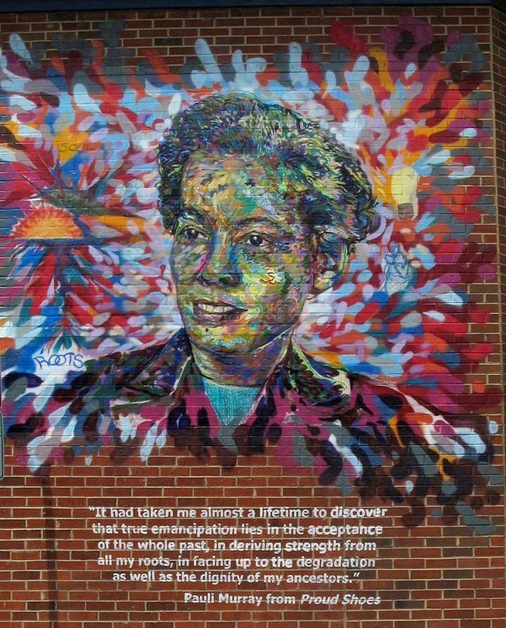
“True emancipation lies in the acceptance of the whole past, in deriving strength from all my roots, in facing up to the degradation as well as the dignity of my ancestors.” -- Pauli Murray

The curriculum centers on the theme: “How do words and images shape our world?” For eighth and higher grade levels, the theme takes on the variation, “Telling and documenting our stories as activism.”

Our goal is for students to advance their skills in critical thinking, narrative writing, creative expression, and to gain a greater awareness of the historical contexts in which Murray continued to fight for human rights. We also hope students will walk away from each activity with insights about the ways history, politics, and identity are connected and a view of themselves as active citizens in their own communities.

Who was Pauli Murray?
The Rev. Dr. Pauli Murray, 1910-1985, was an accomplished American activist who believed in justice, reconciliation, and freedom. They championed the cause of human rights through their work as an author, educator, lawyer, feminist, poet and priest.

Most of us divide our identities in categories such as race, gender, class and sexuality. Pauli Murray resisted this by seeking an integrated body, mind and spirit that embraced all of her identities as a woman, a person of color, a worker, and a member of the LGBTQ community. Descendant from slaves and slave owners, they were a person ahead of their time. Pauli Murray refused to sit in the back of the bus fifteen years before Rosa Parks refused to give up her seat; Murray organized restaurant sit-downs in the nation's capital 20 years before the Greensboro sit-ins.

Pauli Murray became America's first female African-American Episcopal priest 123 years after her enslaved grandmother was baptized at Chapel of the Cross in Chapel Hill, NC, and in 2012 Murray was named an Episcopal saint. Murray challenged doctors in the 1930s to embrace new knowledge about gender and sexuality to address their struggle with gender non-conformity through hormone treatments. As Eleanor Holmes Norton said, Pauli Murray not only lived on the edge of history, Murray seemingly "pulled it along with her.”

Who are we?

The Pauli Murray Center is a nationally significant history site, anchored by Pauli Murray’s childhood home built by her grandparents in 1898 at 906 Carroll Street in Durham, North Carolina. By connecting history to contemporary human rights issues, the Pauli Murray Center will activate visitors of all ages to stand up for peace, equity and justice.
We are open and welcoming to everyone: students, families, visitors to Durham, people of faith, aspiring young LGBTQ activists, civil rights lawyers, divinity school students, artists and poets, history-minded West End neighbors, scholars, and community leaders. Our programming encompasses public history, education, arts and activism. Together we will create the Center as an historic site, incubator, oasis, and sacred space.
Inspiring activism will lead the way to Pauli Murray’s dream for a just world. It is our hope that the Center will launch the next generation of Pauli Murray firebrand leaders – smart, motivated and determined activists who will demand a world that enables all ideas, amplifies many voices and honors everyone’s contributions. We are also renovating their childhood home as a center for dialogue, education, the arts and mobilization for equality and justice. We have collaborated with teacher advisors in Durham, NC to make sure this curriculum is an effective, useful tool in your classroom.

Pauli Murray Center Mission:
The Pauli Murray Center for History and Social Justice lifts up the life and legacy of activist, legal scholar, feminist, poet, and Episcopal priest, the Rev. Dr. Pauli Murray, in order to address enduring inequities and injustices.

Integrating This Curriculum into Unit Maps

Each lesson plan is based on skills, essential questions, and core curriculum standards from the Durham Public Schools ELA Unit Maps 1, 2, 3, and 4. At the beginning of each lesson plan we provide a discussion of how the curriculum lines up with Common Core Standards. We tried to make the lessons flexible so that they could be used for other units at different times of the year.

Primary Grades Lesson Plans

For the primary grades lesson plans, state standards are taken from the third grade level. Please feel free to adapt any lesson plans included for your content area and grade level.

Primary Grades Lesson Plan Index

Setting the Stage Activity
Identity Flower Lesson Plan …………….………………….…..pages 2-4
Student Materials………………………………………..pages 5-8
Introductory Activities
Activity 1: Connecting with Pauli Murray Lesson Plan……………….pages 9-11

Activity 2a: Self-Portraits Lesson Plan………………………………..pages 12-14
Student Materials……………………………………..pages 15-18

Activity 2b: Optional Visual Strategies Activity…………………….. page 14
Student Materials………………………………………page 19-21
Activity 3: Comparing Two Poets……………………………………page 22-23
Student Materials………………………………………page 24-25

Expressing Ourselves Activity Resource

Activity 1: Connecting to Self………………………………………..page 26-27
Student Materials………………………………………page 28-29

Deeper Thinking Activity Resources
Activity 1: Resiliency Comic Strip…………………………………..page 30-31

Activity 2: Life as a NonLinear Timeline……………………………..page 32
Student Materials (Timeline)......................................... pages 33-35
Optional: Timeline Scavenger Hunt Worksheet……………….. pages 36-37

Activity 3: Poetry Workshop Worksheets……………………………..pages 38-39
Student Materials………………………………………page 40-43
Setting The Stage LESSON PLAN
How do words and images shape our world?

Setting the Stage: Identity Flowers

Objectives/Goals: Introduce Pauli Murray, the importance of telling your story, think about writing as activism, consider Murray’s challenges due to the way others perceive them and how telling her story from her own perspective created a way for them to pursue their dreams and goals.
Time: 20-25 minutes
Materials/Handouts:
- Pauli Murray’s identity flower
- Empty identity flowers for students to fill out
- Hand Out: description of who Pauli Murray was and why students should care
Description of Activity:
Students will discuss Pauli Murray’s achievements despite the various roadblocks they faced. Using Pauli Murray’s quotes as a reflection tool, students will begin to think about how telling their own story is an important part of activism and social justice. In thinking through the different aspects of Murray’s identity by assessing and discussing Pauli Murray’s identity flower, students can brainstorm aspects of their lives that make up their story while completing their own identity flower.

Activity Steps:
- Introduce the idea of identity to your students. Identity is things that represent you, your family, where you live, etc. Share an example of your identity flower (or a random example if you prefer) with the students to get them thinking about what aspects there are to identity.
- Introduce the term “civil rights” and the idea that it was a movement that happened everywhere including in Durham. Relate the civil rights movement to them using examples such as, “Think about how we treat each other. Sometimes the boys don’t want to play with the girls during recess. Why do you think that is? Is that fair? If not, what would be considered fair?”
- Supply students with their own empty identity flowers. Have them fill out the petals by thinking about the different parts of how they see themselves and others see them as coming together to create their identities. Invite students to think about how these different aspects come together to create parts of their story. Categories can include things like sports, food they like, how many siblings they have, race, gender, where they live, etc.
- Next, introduce Pauli Murray. Give each student the hand out (found below) with the descriptive paragraph about Pauli Murray. Discuss any vocabulary that the students may not understand. Have them read the paragraphs again individually. The themes that emerge will be revisited in other lessons.

Who was Pauli Murray and why should we care?

Pauli Murray was raised in Durham’s West End neighborhood and fought for human rights for all people her entire life. Murray participated in the civil rights movement, planned some of the first sit-ins, and helped create an important group called the Congress for Racial Equality. They were a feminist and co-founded the National Organization of Women and served as an advisor to President Kennedy on issues related to women’s lives. She was a lawyer, poet and author and published a book of poetry called Dark Testament and a book called Proud Shoes about her family history in Durham. They were religious and became the first African American woman to become an Episcopalian Priest. Murray was an African American woman and member of the LGTBQ community and they believed in giving voice to people who don’t have power, and yet, not many people know about her. Pauli Murray lived from 1910 to 1985. Over her lifetime, they were friends and colleagues with people such as Eleanor Roosevelt, Martin Luther King Jr., Bayard Rustin, Malcolm X, Dorothy Height, Ted Poston, Langston Hughes, Betty Friedan, and President Kennedy, but her story is not told in histories about the civil rights movement or any part of US history. Have you ever heard of their name? Have you learned much about her? What does it mean that someone who did so much isn’t recognized?

- Next, discuss the following quotes by Pauli Murray with your students as a way to link her own views on writing and activism to their own writing as a form of activism through voicing their own stories.

“True emancipation lies in the acceptance of the whole past, in deriving strength from all my roots, in facing up to the degradation as well as the dignity of my ancestors.” — Pauli Murray

“One person plus one typewriter constitutes a movement.” --Pauli Murray

“I’ve been both a winner and a loser, but after I lose someone else wins, because this is a relay race.” --1980 Ms. Magazine Interview

- Display Pauli Murray’s Identity flower and have students consider and discuss the following:
  - What are the first things you notice about Pauli Murray’s identity flower?
  - What petals do you see overlapping and what do you think that could mean for her?
  - Do you see any areas that might contrast with each other? Do you think there are two petals Pauli Murray may have struggled with?

- Supply students with their own identity flowers that are empty. Have them fill out the petals by thinking about the different parts of how they see themselves and others see them as coming together to create their identities. Invite students to think about how these different aspects come together to create parts of their story.

Setting the Stage Worksheet

Who is Pauli Murray?
Pauli Murray was raised in Durham’s West End neighborhood and fought for human rights for all people her entire life. Murray participated in the civil rights movement and planned some of the first sit-ins and helped create an important group called the Congress for Racial Equality. They were a feminist and co-founded the National Organization of Women and served as an advisor to President Kennedy on issues related to women’s lives. They were a lawyer, poet and author and published a book of poetry called Dark Testament and a book called Proud Shoes about her family history in Durham. They were religious and became the first African American woman to become an Episcopalian Priest. Murray was an African American woman and member of the LGTBQ community and they believed in giving voice to people who don’t have power, and yet, not many people know about her. Pauli Murray lived from 1910 to 1985. Over her lifetime, they was friends and colleagues with people such as Eleanor Roosevelt, Martin Luther King Jr., Bayard Rustin, Dorothy Height, Ted Poston, Langston Hughes, Betty Friedan, and President Kennedy, but her story is not told in histories about the civil rights movement or any part of US history. Have you ever heard of Pauli Murray? Have you learned much about her? What does it mean that someone who did so much isn’t recognized?

Quotes:

“True emancipation lies in the acceptance of the whole past, in deriving strength from all my roots, in facing up to the degradation as well as the dignity of my ancestors.” — Pauli Murray

“One person plus one typewriter constitutes a movement.”
--Pauli Murray

“I’ve been both a winner and a loser, but after I lose someone else wins, because this is a relay race.” --1980 Ms. Magazine Interview

Pauli Murray’s Identity Flower

Born female and
sometimes looks Between Working
manly and Middle Class

Black, White, Native American

Relationships
With Women Pauli Murray Poet, Lawyer,
Activist, Scholar, Teacher
INTERSECTIONAL Episcopal Priest
IDENTITY

Hillside HS Graduate
Raised in the Hunter College BA
Episcopal Church Howard Law School and UC Berkeley Law School, 1st African American to
receive JSD of Law Degree
from Yale University
American
Citizen

Blank Identity Flower

Name: _____________

Activity 1: Connecting with Pauli Murray
Subject: English Language Arts
Grade Level: Grade 3
Units: 1, 2, 3, 4
Themes: Story elements (character, setting, problem, solution, theme, main idea), narratives
Standards:
RL 3.1
RL 3.2
RL 3.3
RI 3.2
RI 3.2
W 3.3
W 3.5
Understandings:
Authors of informational text write about a big idea and provide details related to that big idea
Active readers of informational text use words and visuals to acquire facts and information about a topic
Essential Questions:
Is there a right and wrong way to communicate information about a topic?
Skills:
Analyze text by documenting questions, thoughts, connections, and ideas that result from reading the text
Time: 30-40 minute lesson
Materials/Handouts:
- Pauli Murray Prezi (https://prezi.com/view/v8BgT5Y5BGnpXtaW5kbo/)
- Paper
- Markers
- Pencils
Hook Activity: Give your students five minutes to free write about people, places, and activities that are especially important to them. They will reflect on why these things are important to them.

Description of Activity:
Background:
Pauli Murray left their footprint everywhere they went, which can be seen by taking a close look at the people they knew, the places that they lived, and the recognition they have received. Since Pauli Murray’s life story is so long, students will review some of the basic facts about Pauli Murray through a Pauli Murray Bubble map (located at this link: https://prezi.com/view/v8BgT5Y5BGnpXtaW5kbo/) After student view all the different aspects of Pauli’s life, they will then begin to picture themselves at the center of a bubble map and think of the different categories in their life. Students will then start to think of the different people, places, and things that they are connected to and that are connected to them. Listed below are the categories of Pauli Murray’s life that are on the Prezi.
- Jobs
- Places lived
- Schools
- Publications
- Historical movements
- Recognition/ awards

Activity:
After the Prezi is presented to the class; the students will discuss the categories that are familiar to them. For example, students may want to talk about how they know Martin Luther King Jr., or that they know where Hillside High School is located. Students will also discuss items they have never seen, or are confused about. Then students will answer questions about Pauli Murray’s bubble map.

List of possible questions
- What was your first reaction to the bubble map?
- What person on Pauli Murray’s bubble map have you already learned about?
- Why do you think Pauli Murray lived in so many different places?
- Why do you think Pauli Murray was connected to so many different people, places, and things?

Next, students will create their own bubble map based on their life experiences. The purpose of this activity is to give the students a chance to see the many different connections that influence who they are, just like Pauli Murray. Categories can include, but are not limited to:
- Friends/Family
- Schools
- Places lived
- Favorites
  - Colors
  - Number
  - Food
  - TV Show
- Activities/Sports
- Things they have accomplished/ things that they are proud of
- Times when they have been challenged
- What makes them angry?
- What makes them happy?
- Who is your hero?
- Who inspires you?
- When you get older what are some things you want to accomplish?
- What makes you scared?

Extension activity: After the bubble map is completed, the students will connect the different parts of their life by creating a short story based on the information that they put in each category. They will be the main character in the story and it must include at least one fact from every category. The story must include elements such as:
- Characters
- Setting
- Theme
- Main ideas

Activity 2a: “Self-Portraits”
Subject: English Language Arts
Grade Level: Grade 3
Common Core Units: 1, 2, 3, 4
Themes: Story elements (character, setting, problem, solution, theme, main idea), narratives written to tell a story
Standards:
RL 3.3
W 3.3
W 3.5
RI 3.7
SL 3.4
Understandings:
Readers combine clues from the story with their own knowledge to understand ideas in text
Narrative stories describe the experiences of characters in meaningful ways
Active readers of informational text use words and visuals to acquire facts and information about a topic
Essential Questions:
Is there a right or wrong way to tell a story?
When is a picture worth a thousand words?
Skills:
Analyze and describe characters, including their traits, motivations, and feelings
Use analysis of a character to make predictions about the text
Write a narrative
Analyze text by documenting questions, thoughts, connections, and ideas that result from reading the text

Time: 30-40 minute lesson
Materials/Handouts:
- Pauli Murray “Self Portraits” (found below)
- Paper
- Markers
- Pencils
- Visual Strategies Worksheet (found below)

The photos that you are working with come from a photo album created by Pauli Murray that they titled “The Life and Times of an American Called Pauli Murray.” These photos include the names Pauli Murray gave photographs of herself (early “selfies” as it were) such as, “Imp, Crusader, Dude, Priest”. You will be provided with the self-portraits of Pauli Murray, along with the background information on each portrait. We have provided information for teachers about each portrait that may be too advanced for your students. Since you know your classroom better than anyone else, feel free to choose what information you find most suitable to present to your class.
Hook Activity: In this lesson we want students to take away from this activity the idea that being different from the norm is okay and that you must respect other people’s choices to be who they want. You may want to introduce this idea before beginning the activity. For example, you may say, “Girls can play whatever sport they want, and boys can wear pink if they want. That’s okay. Pauli Murray wanted to have short hair and sometimes wear clothes that women don’t usually wear, and that’s what made her so unique. Some people, like Pauli Murray, even see themselves as very different from how the world sees them.” Emphasize that even though everyone is different we all have a responsibility to respect those differences. Have them write down 3 things that make them unique from others and why they are good qualities to have.
Description of Activity:
Present to the class the 4 different “selfies” from Pauli Murray’s photo album (found below). Students will then answer some comprehension questions to give them a chance to think through the photographs and measure the amount of information they obtained and understood about Pauli Murray’s identities. Questions include:

- What was your first reaction to the photos?
- What did you find most interesting about the photos?
- Which one is your favorite and why?
- What does the word “Imp” mean? “Dude”? “Crusader”? “Priest?”
- Why do you think Pauli Murray chose to title one of the photos “The Dude”?
- When you see the word “Imp”, what do you think of?
- Is there anything you don’t understand about the photos?
- Pauli Murray’s name was originally “Anna Pauline.” Why do you think they changed it?
- How do you think people reacted to the way they dressed?

(Optional Section) After students have completed the questions, the teacher will lead the students in a class discussion. Students can discuss the answers to the comprehension questions or the following topics:
- What they found interesting
- What they do not understand
- Or even speculate how she came up with these identities.

Next, students should begin to think about what name, or set of names, that they would use to describe themselves. This brainstorm can be done individually, in groups or as a larger class discussion. The name can be their given name, or include that name if they would like. These names can also be based on categories such as:
- Interests
- Talents
- Likes
- Career goals

After students come up with a name they think describes them, they will create a self-portrait of their own.

Option 1: Students will draw their own self-portrait using art supplies.

Option 2: Students will have a picture taken of them by either the teacher, or using their own devices. They will be encouraged to pose however they want. In this picture the student’s pose will reflect the identity that they have chosen for themselves.

(Optional) After the illustration or photo is made, students have the option to write a short narrative with themselves as the main character. They will write a story based on the portrait they created. The narrative must include:
- Characters
- Setting
- Main Idea/Supporting Details
- Theme

Activity 2b: Extension Option - Teachers can also use this activity as an opportunity to engage with visual learning strategies using the Worksheet option found below after the images from the Pauli Murray photo album.
Pauli Murray: The Imp
“I have never been able to accept what I believe to be an injustice. Perhaps it is because of this I am America’s problem child, and will continue to be.”

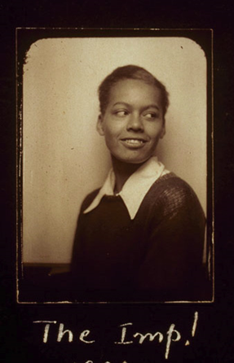
Pauli Murray knew that fighting against social injustices would upset the way things already were. They applied to the University of North Carolina’s graduate school, even though they did not accept people of color into their school. Franklin Porter, the University’s President, did not know what to do, so he asked the state Senate for advice. Murray was not accepted into the school, but many years later the University sent her an honorary degree that Murray did not accept. Pauli was arrested for rebelling against racist seating assignments on a bus to North Carolina while they were fighting to prevent the execution of Odell Walker, a black sharecropper who killed his white landlord in self-defense. Pauli got Franklin Roosevelt to write a letter in support of their application to their law school after graduating at the top of her class at Howard Law School, because they were upset with Harvard’s sexist rules. Murray spoke out about the sexism in the black radical movement and protested against the exclusion of issues that affected women of color in the feminist movement and the National Organization of Women. In “The Imp!” Murray poses for the camera grinning slyly over their shoulder as if content with her past actions and unafraid of their future.

Pauli Murray: The Dude
“Why do I prefer experimentation on the male side, instead of attempted adjustment as a normal woman?”
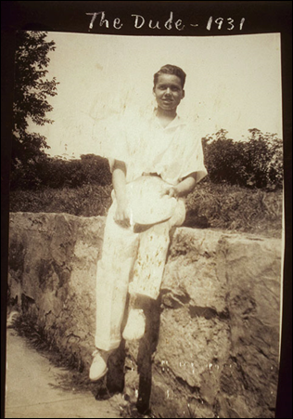
Pauli Murray was born Anna Pauline Murray. They renamed themself a more gender neutral, “Pauli,” during her young adult years. In the 1930s, Murray began talking to doctors about male hormone treatments. They discovered that doctors would only prescribe her female hormone treatments, but refused to take them. Murray recorded her life during this time in a photo album called “The Life and Times of an American Called Pauli Murray.” They took many pictures of themself and their partner Peggie Holmes traveling from Petersburg, Virginia to San Francisco. They also included many images in the album that demonstrate her physical agility. The image they entitled “The Dude” is among several others such as “Mike and Ike,” “Tennis,” and “The Vagabond” that express Murray’s masculinity and ability to do things that people considered not possible for women. Murray used the experiences of her male ancestors and family members to justify the different careers they chose as a civil servant, lawyer, author and priest, all careers that were dominated by men. Murray also fought for women’s rights and feminism; they were one of the first women to fight sex being a category in the 1964 Civil Rights Act. It is unclear how Murray would have identified today, but Murray believed in self-expression and that society should accept people for who they are.

Pauli Murray: The Crusader
“As a human being, I cannot allow myself to be fragmented into Negro at one time, woman at another, or worker at another. I must find a unifying principle in all these movements to which I can adhere…. This, it seems to me, is not only good politics but also may be the price of survival.”
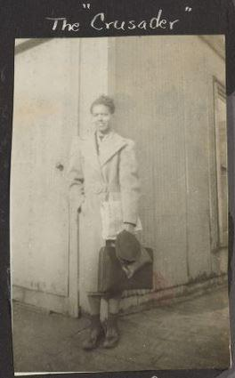
Pauli Murray graduated at the top of her class at Howard Law School, which should have gotten her a spot in Harvard’s Law School, but they were denied a spot because they were a woman. They went to California for school and became the state’s first woman of color to be the deputy attorney general. After Pauli returned to New York, they were the only female and African American lawyer hired by the law firm Paul, Weiss, Rifkin, Wharton, and Garrison. They became an advocate for addressing the connectedness of racial and gendered oppression. After the 1964 Civil Rights Act passed, Murray co-authored “Jane Crow and the Law: Sex discrimination and Title VII,” which used similarities between sex based discrimination with Jim Crow laws. Murray became the first African American to receive a JSD of Law degree from Yale University in 1965. The outfit and label Murray chose for the image “The Crusader” shows Murray in a suit, ready to complete tasks, while at the same time facing many challenges.

Pauli Murray: The Priest
Considering her decision to move from law to priesthood, Murray stated her realization that, “race, sex, all the problems of human rights…were moral and spiritual problems” and that, “we had reached a point where law could not give us the answers.”
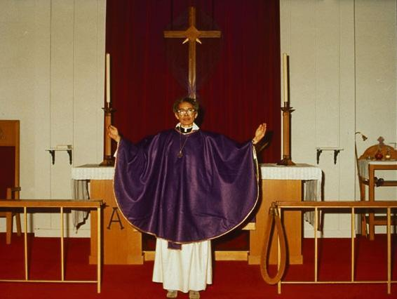
Pauli Murray was born to Agnes Fitzgerald and William Murray in Baltimore in 1910. Agnes Fitzgerald and William Murray were Episcopalians and had Murray baptized in their church, St. James’, which was the South’s first African American Episcopal Church run and operated by African Americans. They grew up attending St. Titus’ in Durham, North Carolina with her Aunt Pauline. By 1977, Pauli Murray became the first African American woman ordained an Episcopal priest. They offered their first Eucharist in the Chapel of the Cross in Chapel Hill, North Carolina which was the same church where her grandmother was baptized as a slave 123 years earlier. Murray served as pastor to two churches, the Church of Atonement in Washington D.C. and the Church of the Holy Nativity in Baltimore, Maryland before retiring at the age of 72.

Visual Strategies Activity

Pick one of the four images of Pauli Murray and answer the following questions about it:

- Write down everything you notice about the photo.

- Turn to a partner and share what you wrote for Number 1. Is there anything you missed?

Answer these questions about the photo you chose:

- What is Pauli Murray wearing?

- What do you think the temperature was like?

- Why do you think they choose to pose the way they did?

- Write 2 sentences that tell a story about what they might have done right before and right after the photo was taken.

- What is the most interesting thing about the photo?

- How is the photo you chose different from the other three photos?

Activity 3: Comparing Two Poets
Subject: English Language Arts
Grade Level: Grade 3
Common Core Units: 1, 2, 3, 4
Themes: compare and contrast, main idea, themes, understanding of a text, describing characters, writing and reflection
Standards:
RL 3.1
L 3.4
W 3.5
Understandings:
Readers combine clues from the story with their own knowledge to understand ideas in text
Active readers use other words in a text to figure out the meaning of an unfamiliar word or phrase
Different kinds of literary text have unique formats which influence how they are read and understood
Essential Questions:
What should I do when I come to a word or phrase I don’t know?
Skills:
Analyze and describe characters, including their traits, motivations, and feelings
Use analysis of a character to make predictions about the text
Use context as a clue to the meaning of a word or phrase.

Time: 30-40 minute lesson
Materials/Handouts:
- Poem from Dark Testament and Other Poems by Pauli Murray
- Poem by Langston Hughes
- Worksheet (found below)

Hook Activity: Pauli Murray and Langston Hughes were friends who shared a similar passion for poetry and social justice. Tell your students to write down a couple things that they have in common with their friends.

Description of Activity:

Students will explore two of Langston Hughes and Pauli Murray’s poems and analyze elements of each. Students will read a poem that Pauli Murray wrote from her book of poems, Dark Testament and Other Poems and a poem written by Langston Hughes about race. The worksheets are located right after this lesson plan. The students will answer comprehension questions, and discuss themes that relate to both. They will answer questions about the main ideas and themes of the excerpts and poems, and discuss the possible emotions and feelings of the characters.

A major theme in both poems is persistence. The activity will end with a writing exercise where the students will write a paragraph about someone in their life who taught them to be persistent, to keep going and not give up. They will write about what they learned from what that person said in addition to what that person did.

Activity 3: Comparing Two Poets Worksheet

Dream Variations
By Langston Hughes

To fling my arms wide
In the face of the sun,
Dance! Whirl! Whirl!
Till the quick day is done.
Rest at pale evening ...
A tall slim tree ...
Night coming tenderly
Black like me.

Color Trouble
By Pauli Murray

If you dislike me just because
My face has more sun than yours,
Then, when you see me, turn and run
But do not try to bar the sun.

Questions:
- What lines of Dream Variations rhyme?

- What lines of Color Trouble rhyme?

- Using context clues, what do you think the word “bar” means in line 4 of Color Trouble?

- What is the main idea of these poems?

- What are the themes of these poems?

- What are the differences in structure between these two poems?

Expressing Ourselves ACTIVITY GUIDE
How do words and images shape our world?

Activity 1: “Connecting to Self”
Subject: English Language Arts
Grade Level: Grade 3
Common Core Units: 1, 2, 3, 4
Themes: image literacy, creative analysis, writing and reflection, public/collaborative art, reflective individual art
Standards:
RL 3.1
RL 3.3
L 3.4
W 3.3
W 3.5
RI 3.7
Understandings:
Readers combine clues from the story with their own knowledge to understand ideas in text
Narrative stories describe the experiences of characters in meaningful ways
Active readers use other words in a text to figure out the meaning of an unfamiliar word or phrase
Active readers of informational text use words and visuals to acquire facts and information about a topic
Essential Questions:
When is a picture worth a thousand words?
What should I do when I come to a word or phrase I don’t know?
Is there a right and wrong way to tell a story?
Skills:
Analyze and describe characters, including their traits, motivations, and feelings
Use analysis of a character to make predictions about the text
Use context as a clue to the meaning of a word or phrase
Write a narrative
Analyze text by documenting questions, thoughts, connections, and ideas that result from reading the text

Time: 2 hours
Materials/Handouts:
- Large Post it for Wall
- Post-its
- Worksheet
- Art materials

Description of Activities:

The activity will begin with a discussion about challenges that the students have faced in their lives and found creative ways to overcome as a way to begin discussing the life and accomplishments of Pauli Murray. There are a few options for activities within this section, including a one sentence poetry activity and a post-it wall. The worksheets accompanying each of these options can be found below. The poetry assignment asks students to think succinctly about expressing themselves through poetry. The post-it wall will have two parts. The first one will be labeled “How do other people describe me?” and the second “How do I describe myself?” Students will write their own descriptors on a post-it, and add it to the growing wall of post-its. This allows them to contribute and see the ideas of others. This activity requires the teacher to provide space for students to stick and view the post-its of their classmates.

Worksheet: Connecting to Self

Writing as Activism: Typewriter

Words are very powerful tools. Pauli Murray wrote their books and poems using a typewriter, which is an old-fashioned machine that prints letters one at a time onto paper. Pauli Murray used a typewriter to write their poems and books before computers and printers were invented.
Think about what message you would want to leave if you only had one line to say it.

Brainstorm 3 ideas here:
_______________________________________________________________________________________________________________________________________________________________________________________________________________________________________________________________________________________________________________________________
Post-It Wall
Pauli Murray chose to name herself lots of different titles, including Imp, Dude, Crusader, and Priest. If you could name yourself what would it be? Is this different from what other people might call you? Think about what you want to write on the Post-It Wall.

- What do other people describe me as?

- How do I describe myself?

Deeper Thinking LESSON PLANS
How do words and images shape our world?

Activity 1: Resiliency Comic Strip
Subject: English Language Arts
Grade Level: Grade 3
Common Core Units: 1, 2, 3, 4
Themes: building narratives, reflecting on challenges, decision-making, alternative media
Standards:
L 3.4
W 3.3
SL 3.4
Understandings:
The interactions between characters and events engage the reader and move a story along
Speakers choose the most important and relevant information to share about a topic and speak clearly in order to be understood
Essential Questions:
How do authors build stories?
Is there a right or wrong way to communicate information about a topic?
Knowledge:
A central message, lesson, or moral is the most important point an author is communicating through a story
Successive parts of stories, dramas, and poems supply meaning and build plot development
Describe and analyze stories, dramas, and poems to understand their format
Explain how chapters, scenes, and stanzas are sequential and build on previous parts
Skills:
Identify and include story elements when recounting a story
Use key details to explain the central message, lesson, or moral of a story
Time: 30-40 minute lesson
Materials/Handouts:
- Paper/pencils
- Coloring materials
Hook Activity: Discuss the meaning of the word resiliency, and have the students make a list of other words that are related to resiliency. Remind them of a time when Pauli Murray was resilient, such as when they didn’t get into UNC Chapel Hill because they were black, but they applied to different schools until they got in at Howard Law School. Then have them come up with an example of what resiliency looks like in their lives. It can be as simple as losing a pencil and finding a new one, or proving someone wrong when told you couldn’t do something. This will get your students thinking about the following activity.

The art work that the students create will give them a chance to reflect on obstacles that they have faced and overcome, while at the same time allowing them to personally connect to the resiliency that Pauli Murray showed in her life. For example, they took obstacles that they faced and turned them into accomplishments. In 1938 Pauli Murray was denied admission to UNC Chapel Hill graduate school because of their race. They went on to enroll in Law School at Howard University. In 1944 Pauli Murray was denied admission to Harvard Law School because of her gender, and instead of giving up they enrolled in the University of California Boalt Hall Law School. In 1945 they received a Masters of Law degree (L.L.M.) from the University of California, Berkeley.

Description of Activity:
Option 1: Students will create a comic strip using a narrative about their own life about a time that they were challenged and came up with a solution to overcome that challenge. They will reflect on how that made them feel (proud, strong, etc.) recalling a time from their life.

Option 2: Students have the option of making a comic strip that recreates a portion of Pauli Murray’s life instead of creating one about their own. This will help them further analyze, in detail, the events that may have occurred in Murray’s life and the consequences of those events and decisions. You may choose some events from Murray’s timeline worksheet for students to choose from.

Extension Option:
Option 3: Individually students will create the captions of their comic strip using a narrative about a time that they were challenged and came up with a solution to overcome that challenge. Then in small groups of 2-5 students will work in an assembly line to make illustrations of the captions that their peers have created. Each student in a group will illustrate at least one caption of each comic strip in the group. While making these illustrations students will discuss why they chose to illustrate the caption in the way they did.
Activity 2: Life as Nonlinear Timeline
Subject: English Language Arts
Grade Level: Grade 3
Common Core Units: 1, 2, 3, 4
Themes: group collaboration, nonlinear history, and personal narrative
Standards:
W 3.3
RI 3.7
RI 3.3
Understandings:
Readers combine clues from the story with their own knowledge to understand ideas in text
Narrative stories describe the experiences of characters in meaningful ways
Speakers choose the most important and relevant information to share about a topic and speak clearly in order to be understood
Essential Questions:
Is there a right and wrong way to tell a story?
Skills:
Use vocabulary related to time, sequence, and cause and effect
Analyze and describe characters, including their traits, motivations, and feelings
Use analysis of a character to make predictions about the text
Time: 30-40 minute lesson; variation in time determined by instructor
Materials/Handouts:
- Large Paper
- Drawing utensils
- Pauli Murray Timeline (found below)
Hook Activity: Talk with your students about how timelines usually go in a straight line but how sometimes that’s not how it feels. When bad things happen, it feels like you have jumped backwards and have to take a different path. Sometimes life is organized into a straight line, but usually there are twists and turns. Have them volunteer to draw on the board an example of what different timelines might look like (curvy, straight, peaked, etc.)
Description of Activity:
The students will divide into groups and recreate parts of Pauli Murray’s life timeline. They will draw pictures associated with a specific date. As a class, they will display the timeline in a nonlinear way that represents the setbacks, twists, and turns in Pauli Murray’s life. For example, have the students stand in a line chronologically, and then one by one have them read their event out loud and talk about the different sides of their careers and identity and what made her who they were. Emphasize resiliency in the face of adversity. This could be adapted to be an individual activity as well.

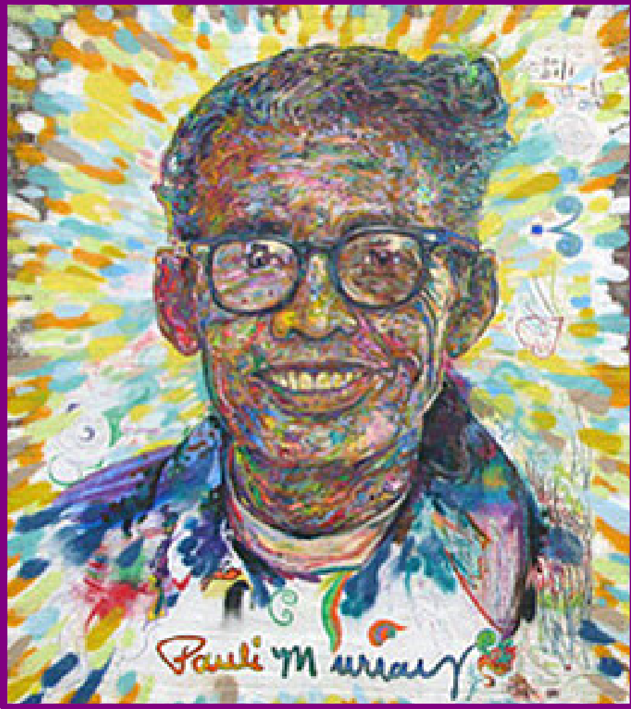

Meet
Pauli Murray

Activist, Poet, Lawyer, Priest
A life of reflection and action

Nov. 20, 1910- Pauli Murray was born in Baltimore, Maryland to Agnes Fitzgerald and William Murray.

1914 - Pauli Murray moves to Durham to live with her aunt, Pauline Fitzgerald Dame, after whom s/he was named. Pauli’s mother had died of a cerebral hemorrhage and her father was unable to care for their six children.

1923 - William Murray is murdered at Crownsville State Hospital by a guard.

1926 - Pauli graduates from Hillside High with a certificate of distinction. They received another high school diploma from Richmond Hills High School in New York in 1927 so that S/he could meet entrance requirements at Hunter College.

1933 - S/he graduates from Hunter College and goes to work for the Works Project Admission (WPA), Workers Defense League and as a teacher in the NYC Remedial Reading Project.

1937 – Pauli seeks gender-affirming medical treatment, including hormone therapy.

1938 - S/he attempts to gain admission as a graduate student at the University of North Carolina at Chapel Hill. S/he is rejected because of her race. While the NAACP supports Murray in challenging the school’s segregationist policies, they decide not to pursue the case for many reasons. Her letter writing campaign, however, brings her to the attention of First Lady Eleanor Roosevelt. They begin a lasting friendship.

1940 - Pauli joins the Fellowship of Reconciliation. While traveling to Durham, S/he is arrested and jailed for protesting Virginia law requiring segregation on buses.
S/he refused to sit on broken seats at the back of the bus. S/he then returns to Virginia to raise money for legal fees for Odell Waller, a black sharecropper accused of murder.

1941 - S/he enters Howard Law School and encounters overt sex discrimination from faculty and students.

1942 - Odell Waller is executed. Murray writes a letter to President Franklin D. Roosevelt on behalf of outraged leaders. S/he criticizes the presidents’ failure to improve conditions for black southerners.

1943 - Murray publishes “Negroes are Fed Up” in Common Sense and an article about the Harlem race riot in the socialist newspaper New York Call. S/he also publishes her famous poem on race relations, “Dark Testament,” in the winter issue of South Today, a magazine published by Lillian Smith and highly regarded for its literary entries and attention to southern racial issues.

1944 - Pauli Murray and fellow students from Howard University take part in a silent demonstration and sit-ins
at a Washington D.C. cafeteria. The students are eventually served, however, the president of Howard orders them to suspend further demonstrations.

1944 - Pauli Murray graduates from Howard Law School first in her class (and the only non-cisgender man). S/he wins a prestigious fellowship and applies to Harvard Law. S/he is rejected because of her gender despite having President Roosevelt (an alumni of Harvard) write a letter to the president of the university on her behalf. S/he enrolls at University of California’s Boalt Hall Law School to work on a graduate degree in law.

1945 – S/he received a Masters of Law degree (L.L.M.) from University of California, Berkeley. Her master’s thesis is entitled, “The Right to Equal Opportunity in Employment.” S/he passes the California state bar.

1945 – Pauli Murray’s aunt Pauline retires after teaching for 60 years and moves to NYC to live with her.
1947 – Pauli Murray is named “Merit Award Winner” by Mademoiselle magazine for her legal work against race and gender discrimination.

1948 – Murray runs for and receives the fourth highest vote total in the New York City council race for Brooklyn’s tenth Senatorial district, barely missing being elected.

1951 – Murray writes the States’ Laws on Race and Color for the Women’s Division of the Methodist Church, which is labeled the “bible” by Thurgood Marshall and other civil rights lawyers.

1952 – Murray is a victim of McCarthyism. S/he is rejected for a US State Department position administered at Cornell University because the people who supplied her references, Eleanor Roosevelt, Thurgood Marshall and A. Phillip Randolph, are considered to be too radical.

1955 - Pauli Murray’s Aunt Pauline dies. On her deathbed, Pauli reads to her from the Book of Common Prayer.

1956 – Pauli Murray’s seminal work Proud Shoes: The Story of an American Family, a biography of her grandparents, their struggles with racial prejudice and early Durham history is published.

1956 – S/he is the only non-cisgender man hired by the NY firm of Paul, Weiss, Rifkin, Wharton, and Garrison.

1960 – Murray travels to Ghana and takes a position as a senior lecturer at the Ghana School of Law in Accra.

1961 - John F. Kennedy appoints Murray to the President’s Commission on the Status of Women Committee (PCSW) on Civil and Political rights. Works with A. Phillip Randolph, Bayard Rustin and Martin L. King, Jr. on civil rights.

1964 – US Civil Rights Act passed. Murray co-authors “Jane Crow and the Law: Sex discrimination and Title VII,” in which S/he draws parallels between sex-based discrimination with Jim Crow laws.

1965 – Murray receives a J.S.D from Yale, the first African-American to receive this doctoral level law degree. Her dissertation was entitled, “Roots of the Racial Crisis: Prologue to Policy.”

1965-1973 – Murray serves on the National Board of Directors for the American Civil Liberties Union (ACLU).

1965-66 - Murray serves as co-counsel in White v. Crook, which successfully eliminates the use of sex and race discrimination in jury selection.

1966 - Along with Betty Friedan and thirty others, Murray is a founding member of National Organization for Women (NOW).

1967 – Murray serves as vice-president of Benedict College in Columbia, SC.

1968-1973 – Murray is tenured as Professor of Law and Politics at Brandeis University.

1973 – At age 62, Murray entered General Theological Seminary prior to the Episcopal Church’s approval of women as candidates for ordination and in 1976 S/he completed the Master of Divinity degree.

December 8, 1977 – Pauli Murray becomes the first African-American person perceived as a woman to be ordained by the Protestant Episcopal Church. S/he offered the Eucharist for the first time on February 13 at Chapel of the Cross, Chapel Hill, NC where her grandmother Cornelia was baptized as an enslaved person.

1982 – Murray is forced to retire because Episcopal Church law requires retirement at age seventy-two.

July 1, 1985 – Pauli Murray dies in Pittsburgh, PA.

1987 – Pauli Murray’s autobiography Song in a Weary Throat: An American Pilgrimage is published.

2011- N.C. Department of Archives and History installs a state highway historic marker honoring Pauli Murray ¼ mile north of her childhood home in Durham.

2012 – Reverend Dr. Pauli Murray is elevated to the status of sainthood by her inclusion in the Book of Holy Women, Holy Men by the General Convention of the Episcopal Church.

2015 – Pauli Murray Family Home Named National Treasure by the Natl. Trust for Historic Preservation.

2016 - Pauli Murray Family Home Named National Historic Landmark by the National Park Service.

Selected Bibliography:
Murray, Pauli Dark Testament and Other Poems. Norwalk,
CT: Silvermine, 1970.
____. Proud Shoes: The Story of an American Family. New York: Harper & Row, 1978.
____. Song in a Weary Throat: An American Pilgrimage. New
York: Harper & Row, 1987. [Reissued, Pauli Murray: The Autobiography of a Black Activist, Feminist, Lawyer, Priest, and Poet. University of Tennessee Press, 1989.
____. States Laws on Race and Color. Cincinnati: Women’s Division of Christian Service, Board of Missions and Church Extension, Methodist Church, 1951.

Azaransky, Sarah. The Dream is Freedom: Pauli Murray and American Democratic Faith. New York: Oxford University Press, 2011.

Bell-Scott, Patricia. The Firebrand and the First Lady: Portrait of a Friendship: Pauli Murray and Eleanor Roosevelt, NY: Random House, 2016

Rosenberg, Rosalind. Jane Crow: The Life of Pauli Murray. New York: Oxford University Press, 2017

Scavenger Hunt

- Look at the timeline. When is Pauli Murray’s birthday? When did they die?

- What event is at the end of the timeline?

- Where did Pauli Murray move in 1914?

- Why did Pauli not get into UNC Chapel Hill in 1938?

- We can think about Pauli Murray’s life and work as connecting the different parts of who they are with how they hoped to see the world. Pauli Murray also believed that “Human rights are indivisible.” They believed that the things that make us unique are just as important as what makes us similar. Think about what makes you similar to others and what makes you unique.

What makes me similar to others is: _______________________________________________________________________________________________________________________________________________________________________________________

What makes me unique from others is: _______________________________________________________________________________________________________________________________________________________________________________________

Activity 3: Poetry Workshop
Subject: English Language Arts
Grade Level: Grade 3
Common Core Units: 1, 2, 3, 4
Themes: main idea, poetry analysis, poetry writing, personal narrative, mood and theme
Standards:
RL 3.1
L 3.4
W 3.5
Understandings:
Readers combine clues from the story with their own knowledge to understand ideas in text
Active readers use other words in a text to figure out the meaning of an unfamiliar word or phrase
Essential Questions:
What should I do when I come to a word or phrase I don’t know?
Skills:
Analyze and describe characters, including their traits, motivations, and feelings
Use analysis of a character to make predictions about the text
Use context as a clue to the meaning of a word or phrase

Time: 30-40 minute lesson
Materials/Handouts:
- Poem(s) from Dark Testament and Other Poems

Hook Activity: After choosing a poem (or multiple) from the ones provided, give your students a copy of the hand out with the poems on it (found after the lesson plan). Read it out loud and have them follow along and tell them to circle any vocabulary words they don’t understand. Go through the definitions of those, and prepare them to read the poem(s) again for comprehension.
Description of Activity:
Students will read and discuss a poem from Dark Testament and Other Poems. Discuss different elements of the poem, including theme, tone, audience, main idea, etc. Questions that follow the poems are included in the hand out. Students will then write their own poems based on their own lives.
Possible poems include:

Tongues
It is quite possible, I think,
That tongues, not money,
Are taproots of evil.
If men were mutes and could not babble
There’d be less need for conferences
Caucuses, rallies, meetings, speeches--
The tongue dragging the body around.

Color Trouble
If you dislike me just because
My face has more sun than yours,
Then, when you see me, turn and run
But do not try to bar the sun.

Tears
Three times I have known tears--
When I loved you,
When I lost you,
When you lost yourself.

Activity 3: Poetry Workshop Hand Out

Tongues

It is quite possible, I think,
That tongues, not money,
Are taproots of evil.
If men were mutes and could not babble
There’d be less need for conferences
Caucuses, rallies, meetings, speeches--
The tongue dragging the body around.

Questions:

- How many lines does the poem have? How many stanzas?

- Using context clues, what do you think the word “taproots” means?

- Has someone ever hurt your feelings with words?

- How did that make you feel?

Color Trouble

If you dislike me just because
My face has more sun than yours,
Then, when you see me, turn and run
But do not try to bar the sun.

Questions:

- How many lines does the poem have? How many stanzas?

- What lines of the poem rhyme?

- Using context clues, what do you think the word “bar” means?

- What is the main idea of the poem?

Tears

Three times I have known tears--
When I loved you,
When I lost you,
When you lost yourself.
Questions:

- How many lines does the poem have?

- How many stanzas?

- What does it mean to stay true to who you are?

Pauli Murray, “Ambition Reached,” Responsibility 4, no. 1 (summer 1946): 12 quoted in Anthony B. Pinn’s “‘America’s Problem Child’: Notes on Pauli Murray’s Theological Development,” Journal of Feminist Studies in Religious Studies in Religion 15, no. 1 (Spring, 1999): 1.
Discrimination on the basis of sex, especially as directed against women.
In favor of extreme changes in government or society.
Crafty in a funny way; full of mischief
The state of being male or female
A substance made by certain cells in the body. Hormones move around the body in the blood and have effects on certain organs and cells. Hormones help control body processes such as growth.
The ability to move or think easily and quickly
Pauli Murray to Kathryn Clarenbach, November 21, 1967, box 51, folder 899, Pauli Murray Collection, Schlesinger Library, Radcliffe Institute, Harvard University.
Harsh, unfair, burdensome acts or demands by a government or other authority.
The fact of being either female or male.
Pauli Murray quoted from an interview with Dr. Genna Rae McNeil in 1976 in The Dream is Freedom: Pauli Murray and American Democratic Faith by Sarah Azaransky pg. 86.
Of or relating to a bishop or government of a church by bishops.
The Christian sacrament of Holy Communion
The Collected Poems of Langston Hughes, p. 40

